**Supplementary Material:**

**Understanding the Reactivity of Unsaturated Alcohols: Experimental and Kinetic Modeling Study of the oxidation of 3-methyl-2-butenol and 3-methyl-3-butenol**

Ruben De Bruyckera, Olivier Herbinetb, Hans-Heinrich Carstensena, Frédérique Battin-Leclercb, Kevin M. Van Geema

a Laboratory for Chemical Technology, Ghent University, Technologiepark 914, 9052 Gent, Belgium

b Laboratoire Réactions et Génie des Procédés, CNRS, Universite de Lorraine, Nancy, France

**Reaction families in Genesys**

Table S 1 k [bimolecular - m³ mol-1 s-1; unimolecular - s-1] = A Tn exp(-Ea/RT) where R = 8.314 10-3 kJ K-1 mol -1

|  |  |  |  |  |  |  |
| --- | --- | --- | --- | --- | --- | --- |
| **Reaction family** |  | **Comment** | **Kinetic parameters** | | | **Ref** |
|  |  |  | ***A*** | ***n*** | ***Ea*** |  |
| **Hydrogen abstraction** |  |  |  |  |  |  |
| *Intermolecular* |  |  |  |  |  |  |
| by C• from C-H |  |  | Group additivity | | | [1, 2] |
| H abstr from C(=O)-**H** by CH3 | 2.5e-6 | 3.6 | 18.1 | [3] |
| by H• from C-H |  |  | Group additivity | | | [4] |
| H abstr from C(=O)-**H** | 7.15e-1 | 2.4 | 6.6 | [3] |
| by •OH from C-H |  | R1, R2, R3 alkyl chains or H atoms | Rate rules for alkanes | | | [5, 6] |
| R1, R2 H atoms  R3 C=C | 7.80e-1 | 2.3 | -5.7 | [7] |
| R1 H atom  R2 alkyl chain  R3 C=C | 7.50e-2 | 2.4 | -3.9 | [7] |
| R1 H atom  R2 OH  R3 alkyl chain | 1.15e-2 | 2.6 | -8.7 | [7] |
| R1 H atom  R2 OH  R3 C=C | 2.55e-2 | 2.6 | -13.3 | [7] |
| H abstr from C(=O)-**H** | 6.13e-2 | 2.7 | -19.2 | [3] |
| by HO2• from C-H |  | R1, R2, R3 alkyl chains or H atoms | Rate rules for alkanes | | | [8] |
| R1, R2 or R3 OH | 1.23e-11 | 5.26 | 31.3 | [9] |
| R1, R2 or R3 C=C | 7.68e-2 | 4.4 | 56.7 | [10] |
| H abstr from C(=O)-**H** | 1.18e-10 | 4.9 | 15.4 | [3] |
| by O2 from C-H |  |  | 1.00e7 | 0.0 | ΔHr | [11, 12] |
| *Intramolecular* |  |  |  |  |  |  |
| by C• from C-H |  |  | Group additivity + rate rule  A = function of # hindered rotors in TS  Ea = ring strain in TS + activation energy analogous bimolecular reaction | | | [1, 2, 13] |
| by R-O-O• from C-H |  | Formation of an alkyl radical | Rate rules for alkanes | | | [14] |
| Formation of an allylic radical | 2.24e6 | 1.29 | 59.6 | [15] |
| by R-O-O• from O-H |  | Analogy with 2-peroxy-2-methyl-propan-1-ol | 2.91e12 | -0.23 | 93.3 | [16] |
| **β-scission / radical addition** | |  |  |  |  |  |
| *Carbon-centered radicals* | |  |  |  |  |  |
| •C-C-C ⇄ C=C + •C |  |  | Group additivity | | | [17] |
| •C-C-H ⇄ C=C + •H |  |  | Group additivity | | | [18] |
| •C-C-OH ⇄ C=C+ •OH |  | Analogy with  2-hydroxy-ethyl to ethene plus OH | 3.00e13 | 0.0 | 112.1 | a |
| •C-O-H ⇄ C=O+ •H |  | Analogy with acetaldehyde plus H to 1-hydroxy-ethyl | 1.10e8 | 0.0 | 44.7 | a |
| •C-O-OH ⇄ C=O+ •OH |  |  | 9.00e14 | 0.0 | 6.28 |  |
| •C-C-O-O-H ⇄ C=C+ HO2• |  |  | Rate rules for alkanes | | | [14] |
| *Oxygen-centered radicals* | |  |  |  |  |  |
| •O-C-C ⇄ C=O+ •C |  | R1 alkyl  Analogy with 2-oxy-propane | 6.00e13 | 0.22 | 59.0 | a |
| R1 C=C  Analogy with allyloxy | 2.70e14 | 0.00 | 100.0 | [19] |
| •O-C-H ⇄ C=O+ •H |  | R1 or R2 C=C.  Analogy with allyloxy | 1.17e10 | 1.00 | 77.6 | [19] |
| **α-scission** |  |  |  |  |  |  |
| C-C(=O)• ⇄ C• + CO |  | Analogy with acetyl radical | 3.30e12 | 0.62 | 72.4 | a |
| **Concerted reactions** |  |  |  |  |  |  |
| •O-O-C-C-H ⇄ HO2• + C=C |  |  | Rate rules for alkanes | | | [14] |
| Formation of cyclic ethers from hydoperoxyl-alkyl radicals |  |  | Rate rules for alkanes | | | [14] |
| •O-O-C-OH ⇄ HO2• + C=O |  | Analogy with alpha-hydroxy-ethylperoxy | 2.60e8 | 1.128 | 44.5 | [20] |
| **Oxygen addition on carbon-centered radicals** | |  |  |  |  |  |
| C• + O2 ⇄ C-O-O• |  | R1, R2, R3 alkyl chains or H atoms | Rate rules for alkanes | | | [14] |
| R1 C=C | 5.78e1 | 1.59 | 4.5 | [21] |
| R1 OH | 4.05e7 | -0.31 | -1.4 | [9] |
| **Recombination / scission** | |  |  |  |  |  |
| C-O-O-H ⇄ CO• + •OH |  | Analogy with allylhydroperoxide | 3.35e10 | 0.60 | -8.8 | [19] |
| C• + HO2• ⇄ C-O-O-H |  | Analogy with allylhydroperoxide | 1.59e20 | -1.50 | 179.3 | [19] |
|  | a CBS-QB3 calculations |  |  |  |  |  |

**Model performance isoprenol oxidation and pyrolysis**

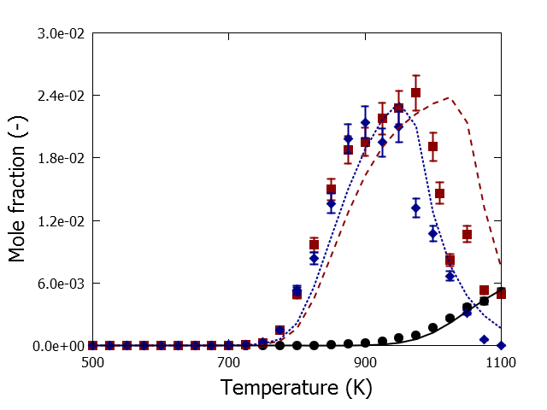

Fig. S 1 CO mole fractions as a function of temperature for isoprenol oxidation and pyrolysis in a jet-stirred reactor, P=0.107 MPa, FV =4.06 10-5 m3 s-1, xisoprenol,0=0.008, φ=0.5 (blue), φ=1.0 (red) and φ=∞ (black): symbols, experimental mole fraction profile; lines, mole fraction profiles calculated with CHEMKIN using the perfectly stirred reactor model and the developed kinetic model

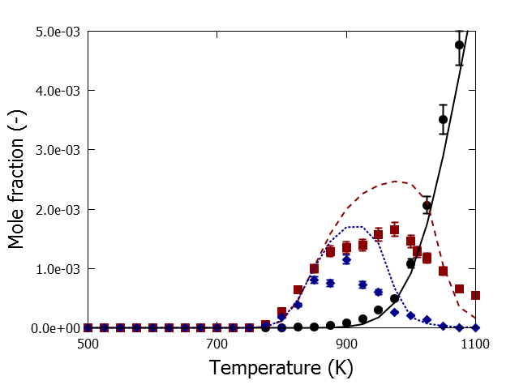

Fig. S 2 CH4 mole fractions as a function of temperature for isoprenol oxidation and pyrolysis in a jet-stirred reactor, P=0.107 MPa, FV =4.06 10-5 m3 s-1, xisoprenol,0=0.008, φ=0.5 (blue), φ=1.0 (red) and φ=∞ (black): symbols, experimental mole fraction profile; lines, mole fraction profiles calculated with CHEMKIN using the perfectly stirred reactor model and the developed kinetic model

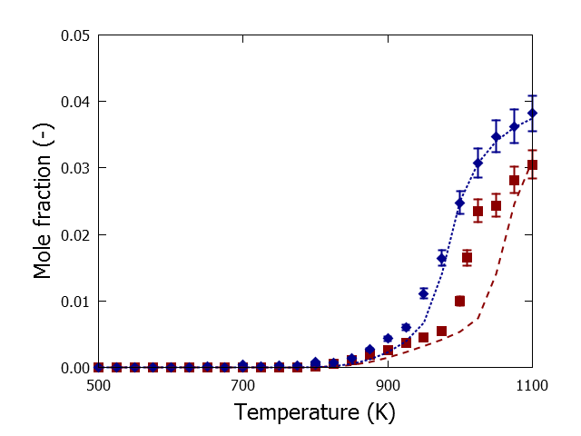

Fig. S 3 CO2 mole fractions as a function of temperature for isoprenol oxidation and pyrolysis in a jet-stirred reactor, P=0.107 MPa, FV =4.06 10-5 m3 s-1, xisoprenol,0=0.008, φ=0.5 (blue), φ=1.0 (red) and φ=∞ (black): symbols, experimental mole fraction profile; lines, mole fraction profiles calculated with CHEMKIN using the perfectly stirred reactor model and the developed kinetic model

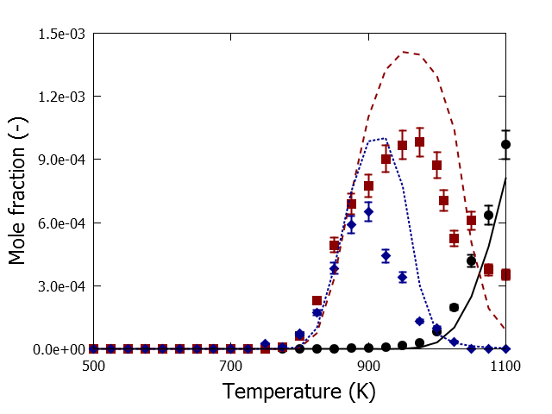

Fig. S 4 C2H4 mole fractions as a function of temperature for isoprenol oxidation and pyrolysis in a jet-stirred reactor, P=0.107 MPa, FV =4.06 10-5 m3 s-1, xisoprenol,0=0.008, φ=0.5 (blue), φ=1.0 (red) and φ=∞ (black): symbols, experimental mole fraction profile; lines, mole fraction profiles calculated with CHEMKIN using the perfectly stirred reactor model and the developed kinetic model

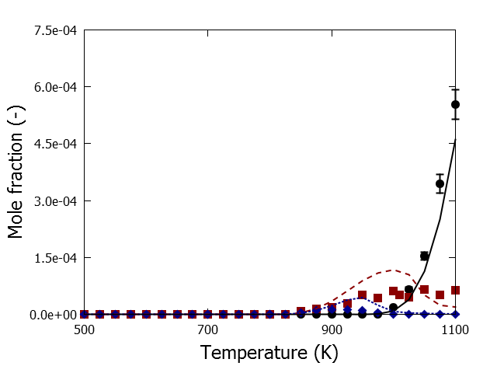

Fig. S 5 C2H2 mole fractions as a function of temperature for isoprenol oxidation and pyrolysis in a jet-stirred reactor, P=0.107 MPa, FV =4.06 10-5 m3 s-1, xisoprenol,0=0.008, φ=0.5 (blue), φ=1.0 (red) and φ=∞ (black): symbols, experimental mole fraction profile; lines, mole fraction profiles calculated with CHEMKIN using the perfectly stirred reactor model and the developed kinetic model

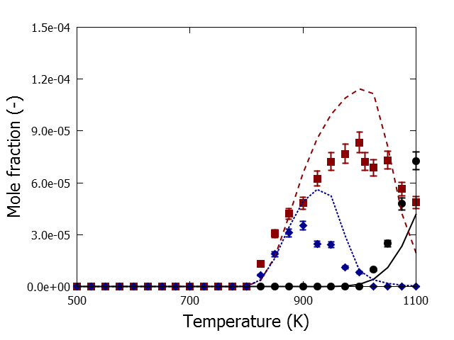

Fig. S 6 C2H6 mole fractions as a function of temperature for isoprenol oxidation and pyrolysis in a jet-stirred reactor, P=0.107 MPa, FV =4.06 10-5 m3 s-1, xisoprenol,0=0.008, φ=0.5 (blue), φ=1.0 (red) and φ=∞ (black): symbols, experimental mole fraction profile; lines, mole fraction profiles calculated with CHEMKIN using the perfectly stirred reactor model and the developed kinetic model

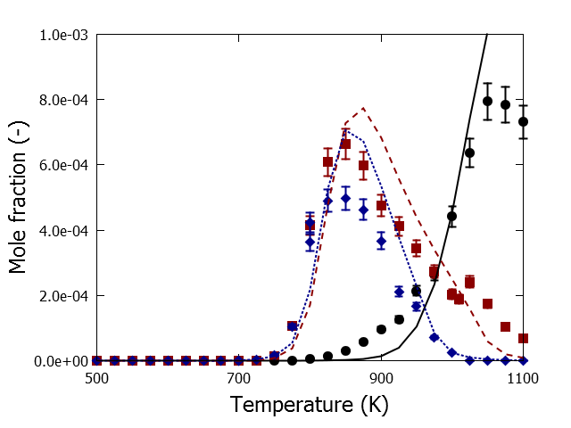

Fig. S 7 C3H6 mole fractions as a function of temperature for isoprenol oxidation and pyrolysis in a jet-stirred reactor, P=0.107 MPa, FV =4.06 10-5 m3 s-1, xisoprenol,0=0.008, φ=0.5 (blue), φ=1.0 (red) and φ=∞ (black): symbols, experimental mole fraction profile; lines, mole fraction profiles calculated with CHEMKIN using the perfectly stirred reactor model and the developed kinetic model

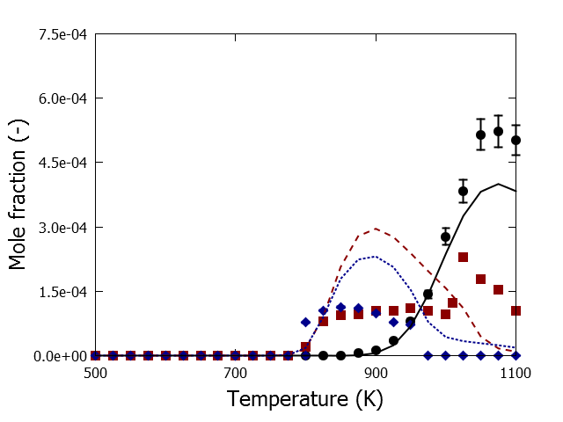

Fig. S 8 Allene mole fractions as a function of temperature for isoprenol oxidation and pyrolysis in a jet-stirred reactor, P=0.107 MPa, FV =4.06 10-5 m3 s-1, xisoprenol,0=0.008, φ=0.5 (blue), φ=1.0 (red) and φ=∞ (black): symbols, experimental mole fraction profile; lines, mole fraction profiles calculated with CHEMKIN using the perfectly stirred reactor model and the developed kinetic model

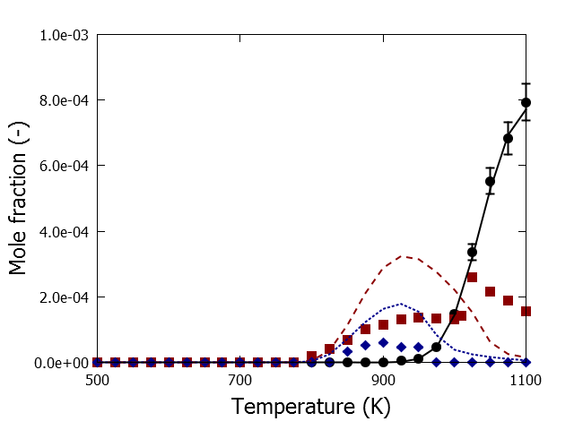

Fig. S 9 Propyne mole fractions as a function of temperature for isoprenol oxidation and pyrolysis in a jet-stirred reactor, P=0.107 MPa, FV =4.06 10-5 m3 s-1, xisoprenol,0=0.008, φ=0.5 (blue), φ=1.0 (red) and φ=∞ (black): symbols, experimental mole fraction profile; lines, mole fraction profiles calculated with CHEMKIN using the perfectly stirred reactor model and the developed kinetic model

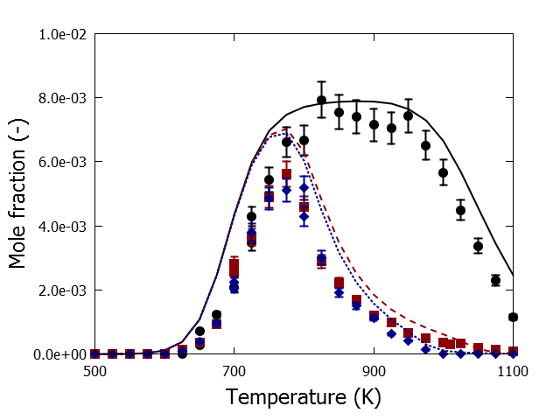

Fig. S 10 CH2O mole fractions as a function of temperature for isoprenol oxidation and pyrolysis in a jet-stirred reactor, P=0.107 MPa, FV =4.06 10-5 m3 s-1, xisoprenol,0=0.008, φ=0.5 (blue), φ=1.0 (red) and φ=∞ (black): symbols, experimental mole fraction profile; lines, mole fraction profiles calculated with CHEMKIN using the perfectly stirred reactor model and the developed kinetic model

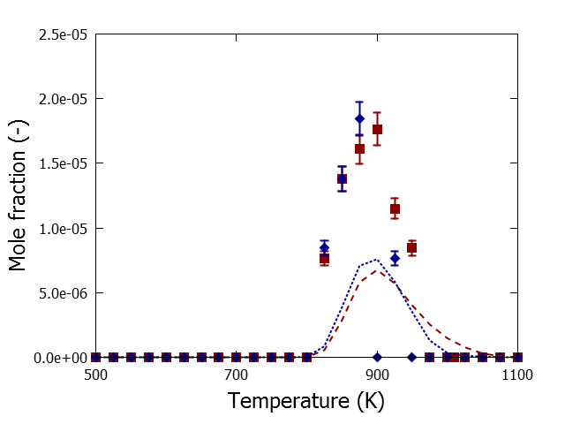

Fig. S 11 Oxiran mole fractions as a function of temperature for isoprenol oxidation and pyrolysis in a jet-stirred reactor, P=0.107 MPa, FV =4.06 10-5 m3 s-1, xisoprenol,0=0.008, φ=0.5 (blue), φ=1.0 (red) and φ=∞ (black): symbols, experimental mole fraction profile; lines, mole fraction profiles calculated with CHEMKIN using the perfectly stirred reactor model and the developed kinetic model

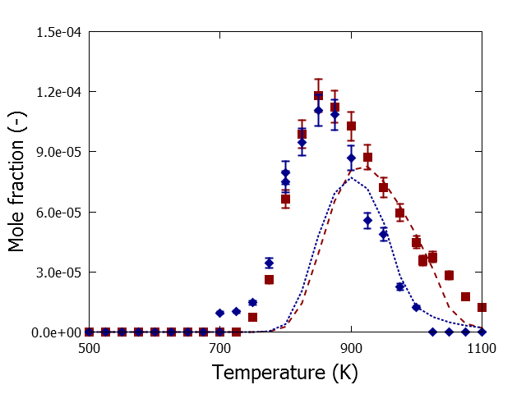

Fig. S 12 Acetaldehyde mole fractions as a function of temperature for isoprenol oxidation and pyrolysis in a jet-stirred reactor, P=0.107 MPa, FV =4.06 10-5 m3 s-1, xisoprenol,0=0.008, φ=0.5 (blue), φ=1.0 (red) and φ=∞ (black): symbols, experimental mole fraction profile; lines, mole fraction profiles calculated with CHEMKIN using the perfectly stirred reactor model and the developed kinetic model

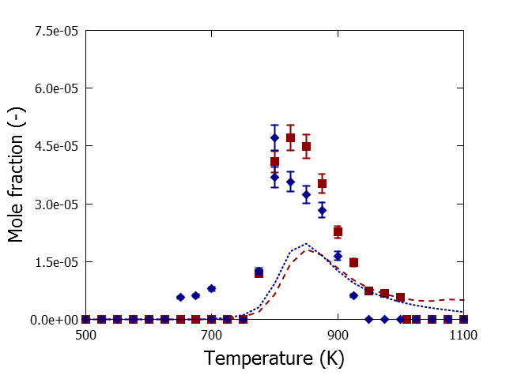

Fig. S 13 Methanol mole fractions as a function of temperature for isoprenol oxidation and pyrolysis in a jet-stirred reactor, P=0.107 MPa, FV =4.06 10-5 m3 s-1, xisoprenol,0=0.008, φ=0.5 (blue), φ=1.0 (red) and φ=∞ (black): symbols, experimental mole fraction profile; lines, mole fraction profiles calculated with CHEMKIN using the perfectly stirred reactor model and the developed kinetic model

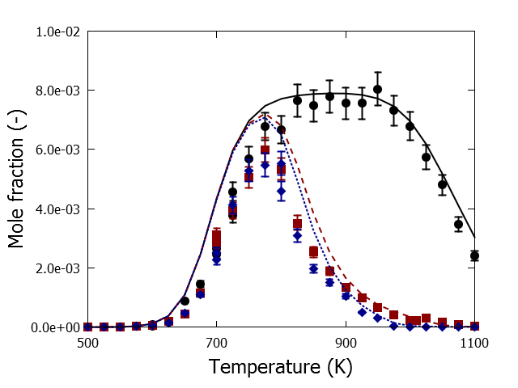

Fig. S 14 Isobutene mole fractions as a function of temperature for isoprenol oxidation and pyrolysis in a jet-stirred reactor, P=0.107 MPa, FV =4.06 10-5 m3 s-1, xisoprenol,0=0.008, φ=0.5 (blue), φ=1.0 (red) and φ=∞ (black): symbols, experimental mole fraction profile; lines, mole fraction profiles calculated with CHEMKIN using the perfectly stirred reactor model and the developed kinetic model

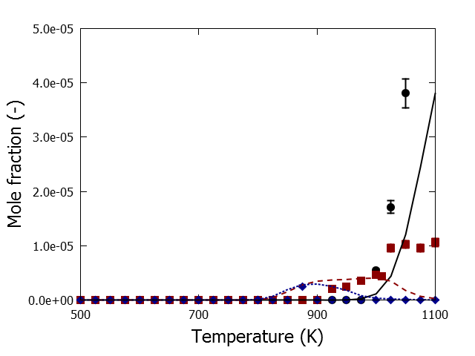

Fig. S 15 1,3-butadiene mole fractions as a function of temperature for isoprenol oxidation and pyrolysis in a jet-stirred reactor, P=0.107 MPa, FV =4.06 10-5 m3 s-1, xisoprenol,0=0.008, φ=0.5 (blue), φ=1.0 (red) and φ=∞ (black): symbols, experimental mole fraction profile; lines, mole fraction profiles calculated with CHEMKIN using the perfectly stirred reactor model and the developed kinetic model

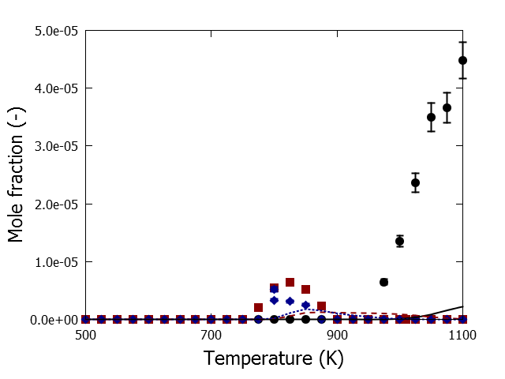

Fig. S 16 2-butene mole fractions as a function of temperature for isoprenol oxidation and pyrolysis in a jet-stirred reactor, P=0.107 MPa, FV =4.06 10-5 m3 s-1, xisoprenol,0=0.008, φ=0.5 (blue), φ=1.0 (red) and φ=∞ (black): symbols, experimental mole fraction profile; lines, mole fraction profiles calculated with CHEMKIN using the perfectly stirred reactor model and the developed kinetic model

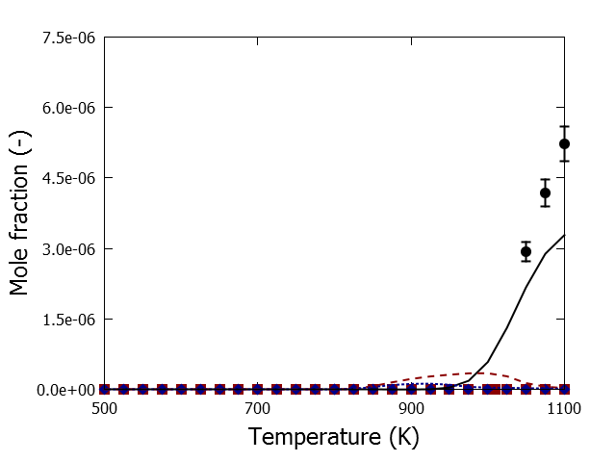

Fig. S 17 1,2-butadiene mole fractions as a function of temperature for isoprenol oxidation and pyrolysis in a jet-stirred reactor, P=0.107 MPa, FV =4.06 10-5 m3 s-1, xisoprenol,0=0.008, φ=0.5 (blue), φ=1.0 (red) and φ=∞ (black): symbols, experimental mole fraction profile; lines, mole fraction profiles calculated with CHEMKIN using the perfectly stirred reactor model and the developed kinetic model

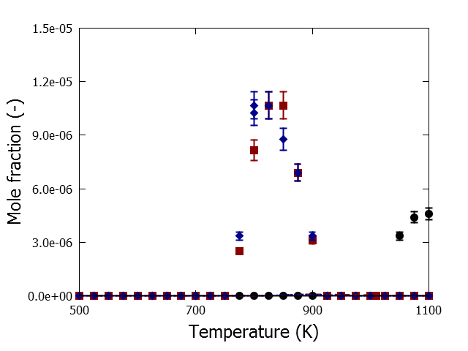

Fig. S 18 furan mole fractions as a function of temperature for isoprenol oxidation and pyrolysis in a jet-stirred reactor, P=0.107 MPa, FV =4.06 10-5 m3 s-1, xisoprenol,0=0.008, φ=0.5 (blue), φ=1.0 (red) and φ=∞ (black): symbols, experimental mole fraction profile; lines, mole fraction profiles calculated with CHEMKIN using the perfectly stirred reactor model and the developed kinetic model

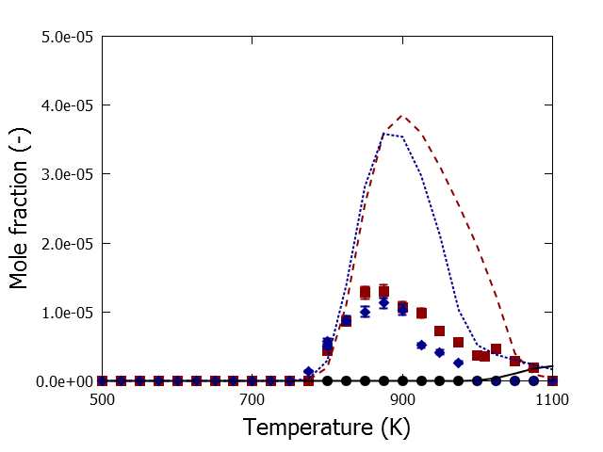

Fig. S 19 acrolein mole fractions as a function of temperature for isoprenol oxidation and pyrolysis in a jet-stirred reactor, P=0.107 MPa, FV =4.06 10-5 m3 s-1, xisoprenol,0=0.008, φ=0.5 (blue), φ=1.0 (red) and φ=∞ (black): symbols, experimental mole fraction profile; lines, mole fraction profiles calculated with CHEMKIN using the perfectly stirred reactor model and the developed kinetic model

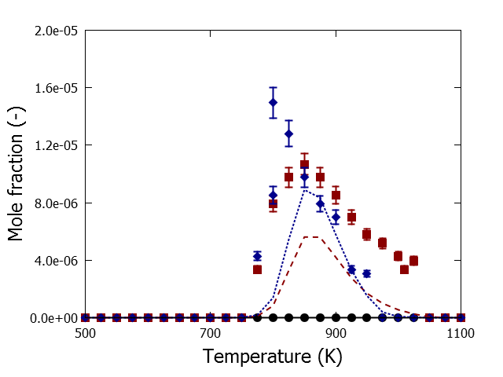

Fig. S 20 Propanal mole fractions as a function of temperature for isoprenol oxidation and pyrolysis in a jet-stirred reactor, P=0.107 MPa, FV =4.06 10-5 m3 s-1, xisoprenol,0=0.008, φ=0.5 (blue), φ=1.0 (red) and φ=∞ (black): symbols, experimental mole fraction profile; lines, mole fraction profiles calculated with CHEMKIN using the perfectly stirred reactor model and the developed kinetic model

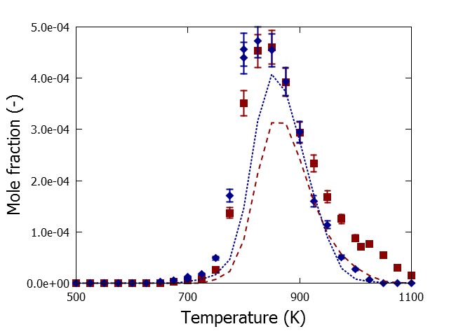

Fig. S 21 Acetone mole fractions as a function of temperature for isoprenol oxidation and pyrolysis in a jet-stirred reactor, P=0.107 MPa, FV =4.06 10-5 m3 s-1, xisoprenol,0=0.008, φ=0.5 (blue), φ=1.0 (red) and φ=∞ (black): symbols, experimental mole fraction profile; lines, mole fraction profiles calculated with CHEMKIN using the perfectly stirred reactor model and the developed kinetic model

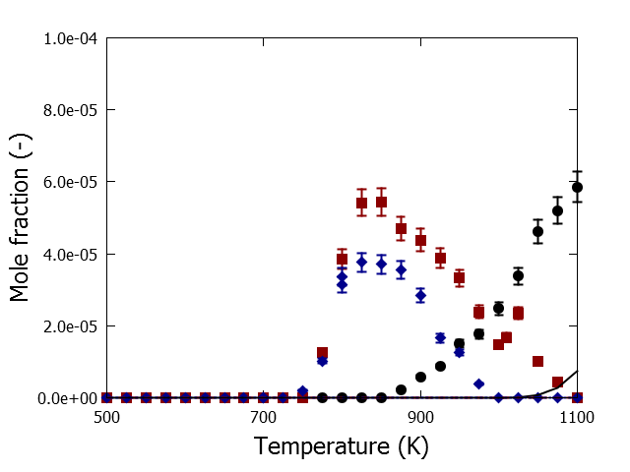

Fig. S 22 CPD mole fractions as a function of temperature for isoprenol oxidation and pyrolysis in a jet-stirred reactor, P=0.107 MPa, FV =4.06 10-5 m3 s-1, xisoprenol,0=0.008, φ=0.5 (blue), φ=1.0 (red) and φ=∞ (black): symbols, experimental mole fraction profile; lines, mole fraction profiles calculated with CHEMKIN using the perfectly stirred reactor model and the developed kinetic model

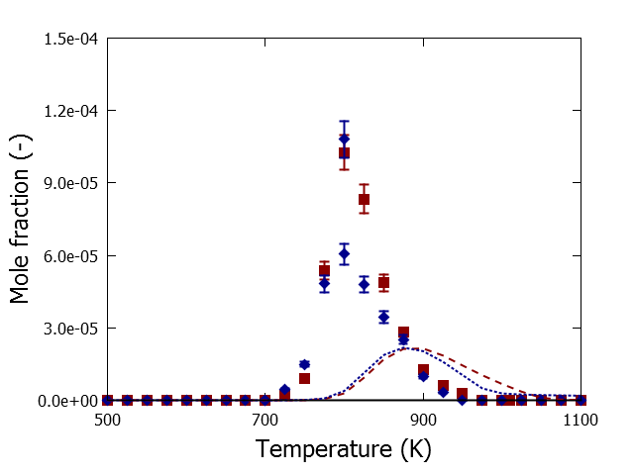

Fig. S 23 Propenol mole fractions as a function of temperature for isoprenol oxidation and pyrolysis in a jet-stirred reactor, P=0.107 MPa, FV =4.06 10-5 m3 s-1, xisoprenol,0=0.008, φ=0.5 (blue), φ=1.0 (red) and φ=∞ (black): symbols, experimental mole fraction profile; lines, mole fraction profiles calculated with CHEMKIN using the perfectly stirred reactor model and the developed kinetic model

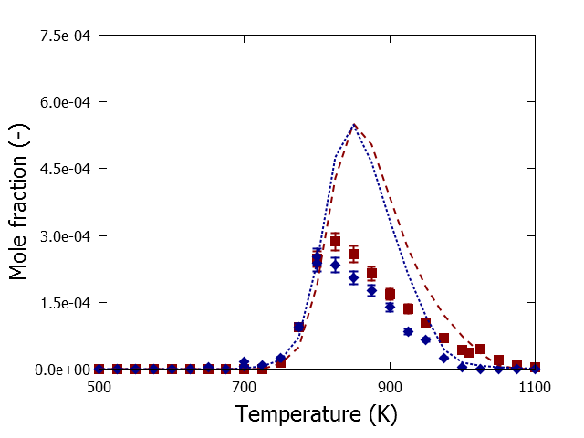

Fig. S 24 Methacrolein mole fractions as a function of temperature for isoprenol oxidation and pyrolysis in a jet-stirred reactor, P=0.107 MPa, FV =4.06 10-5 m3 s-1, xisoprenol,0=0.008, φ=0.5 (blue), φ=1.0 (red) and φ=∞ (black): symbols, experimental mole fraction profile; lines, mole fraction profiles calculated with CHEMKIN using the perfectly stirred reactor model and the developed kinetic model

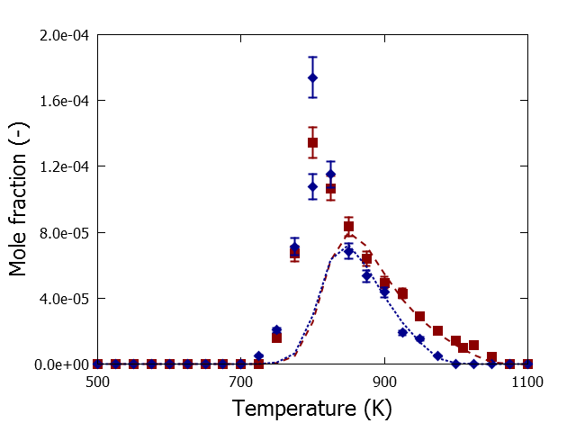

Fig. S 25 2-methyl-propanal mole fractions as a function of temperature for isoprenol oxidation and pyrolysis in a jet-stirred reactor, P=0.107 MPa, FV =4.06 10-5 m3 s-1, xisoprenol,0=0.008, φ=0.5 (blue), φ=1.0 (red) and φ=∞ (black): symbols, experimental mole fraction profile; lines, mole fraction profiles calculated with CHEMKIN using the perfectly stirred reactor model and the developed kinetic model

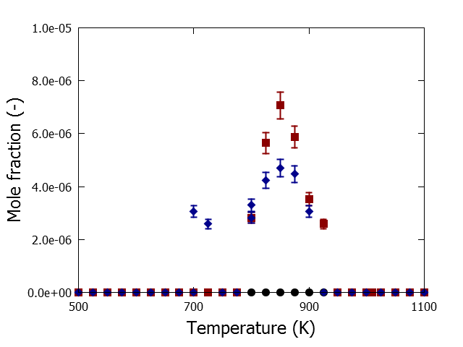

Fig. S 26 3-methyl-furan mole fractions as a function of temperature for isoprenol oxidation and pyrolysis in a jet-stirred reactor, P=0.107 MPa, FV =4.06 10-5 m3 s-1, xisoprenol,0=0.008, φ=0.5 (blue), φ=1.0 (red) and φ=∞ (black): symbols, experimental mole fraction profile; lines, mole fraction profiles calculated with CHEMKIN using the perfectly stirred reactor model and the developed kinetic model

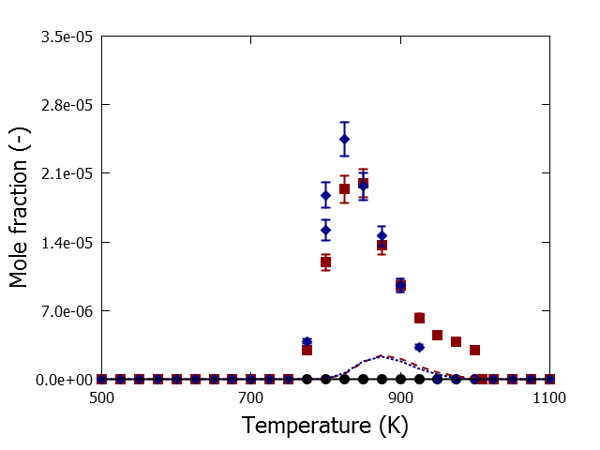

Fig. S 27 butanone mole fractions as a function of temperature for isoprenol oxidation and pyrolysis in a jet-stirred reactor, P=0.107 MPa, FV =4.06 10-5 m3 s-1, xisoprenol,0=0.008, φ=0.5 (blue), φ=1.0 (red) and φ=∞ (black): symbols, experimental mole fraction profile; lines, mole fraction profiles calculated with CHEMKIN using the perfectly stirred reactor model and the developed kinetic model

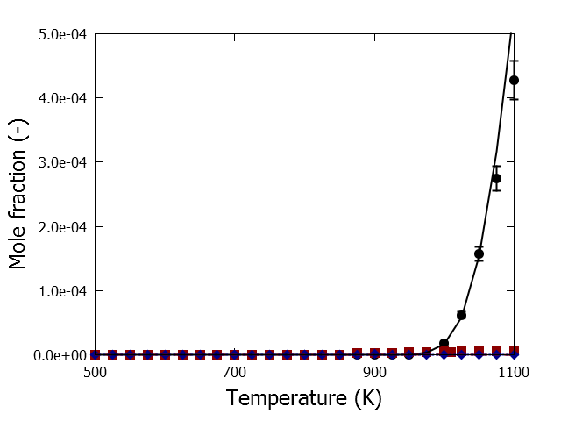

Fig. S 28 benzene mole fractions as a function of temperature for isoprenol oxidation and pyrolysis in a jet-stirred reactor, P=0.107 MPa, FV =4.06 10-5 m3 s-1, xisoprenol,0=0.008, φ=0.5 (blue), φ=1.0 (red) and φ=∞ (black): symbols, experimental mole fraction profile; lines, mole fraction profiles calculated with CHEMKIN using the perfectly stirred reactor model and the developed kinetic model

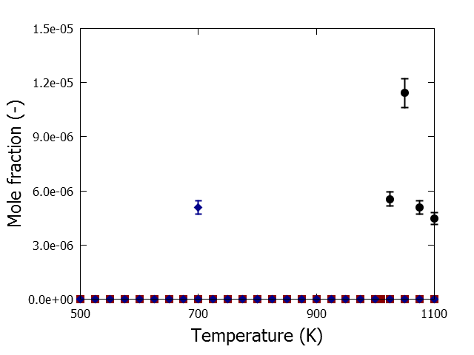

Fig. S 29 cyclohexadiene mole fractions as a function of temperature for isoprenol oxidation and pyrolysis in a jet-stirred reactor, P=0.107 MPa, FV =4.06 10-5 m3 s-1, xisoprenol,0=0.008, φ=0.5 (blue), φ=1.0 (red) and φ=∞ (black): symbols, experimental mole fraction profile; lines, mole fraction profiles calculated with CHEMKIN using the perfectly stirred reactor model and the developed kinetic model

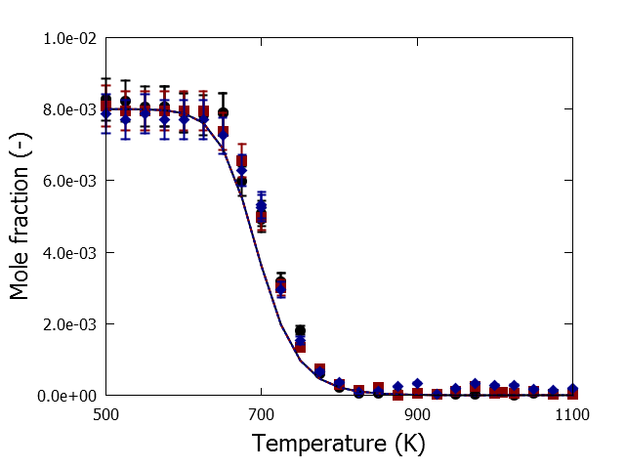

Fig. S 30 isoprenol mole fractions as a function of temperature for isoprenol oxidation and pyrolysis in a jet-stirred reactor, P=0.107 MPa, FV =4.06 10-5 m3 s-1, xisoprenol,0=0.008, φ=0.5 (blue), φ=1.0 (red) and φ=∞ (black): symbols, experimental mole fraction profile; lines, mole fraction profiles calculated with CHEMKIN using the perfectly stirred reactor model and the developed kinetic model

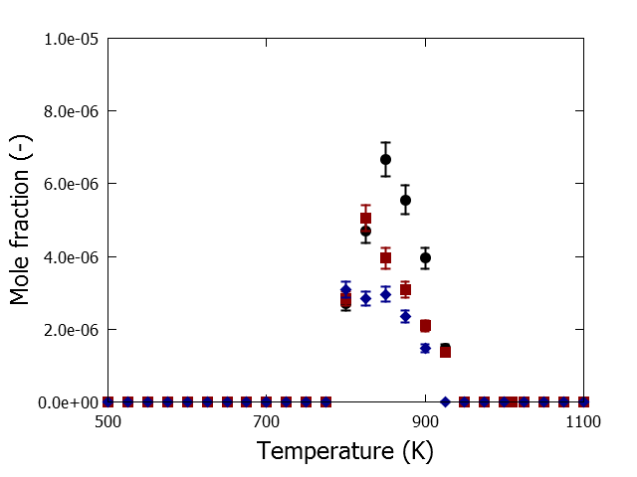

Fig. S 31 2-methyl-1,5-hexadiene mole fractions as a function of temperature for isoprenol oxidation and pyrolysis in a jet-stirred reactor, P=0.107 MPa, FV =4.06 10-5 m3 s-1, xisoprenol,0=0.008, φ=0.5 (blue), φ=1.0 (red) and φ=∞ (black): symbols, experimental mole fraction profile; lines, mole fraction profiles calculated with CHEMKIN using the perfectly stirred reactor model and the developed kinetic model

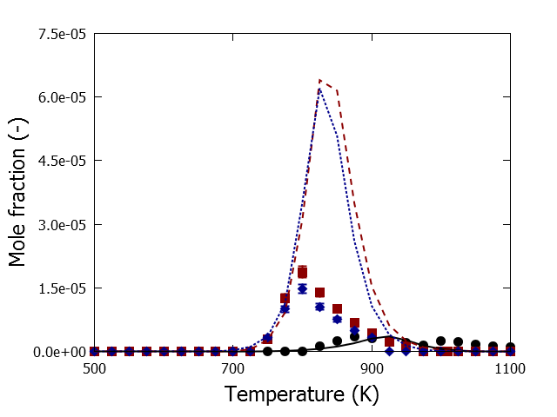

Fig. S 32 2,5-dimethyl-1,5-hexadiene mole fractions as a function of temperature for isoprenol oxidation and pyrolysis in a jet-stirred reactor, P=0.107 MPa, FV =4.06 10-5 m3 s-1, xisoprenol,0=0.008, φ=0.5 (blue), φ=1.0 (red) and φ=∞ (black): symbols, experimental mole fraction profile; lines, mole fraction profiles calculated with CHEMKIN using the perfectly stirred reactor model and the developed kinetic model

**Model performance prenol oxidation and pyrolysis**

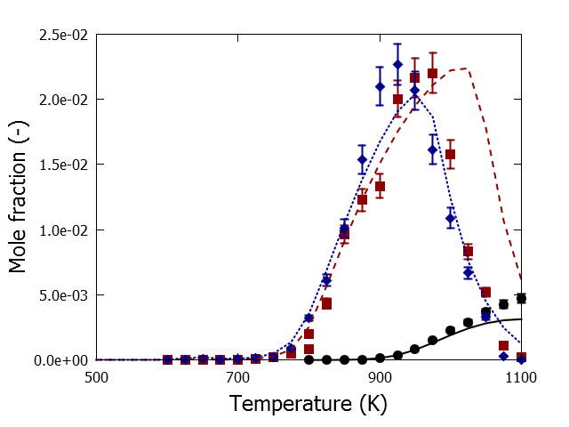

Fig. S 33 CO mole fractions as a function of temperature for prenol oxidation and pyrolysis in a jet-stirred reactor, P=0.107 MPa, FV =4.06 10-5 m3 s-1, xprenol,0=0.008, φ=0.5 (blue), φ=1.0 (red) and φ=∞ (black): symbols, experimental mole fraction profile; lines, mole fraction profiles calculated with CHEMKIN using the perfectly stirred reactor model and the developed kinetic model

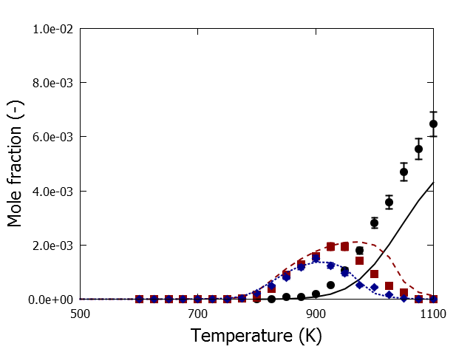

Fig. S 34 CH4 mole fractions as a function of temperature for prenol oxidation and pyrolysis in a jet-stirred reactor, P=0.107 MPa, FV =4.06 10-5 m3 s-1, xprenol,0=0.008, φ=0.5 (blue), φ=1.0 (red) and φ=∞ (black): symbols, experimental mole fraction profile; lines, mole fraction profiles calculated with CHEMKIN using the perfectly stirred reactor model and the developed kinetic model

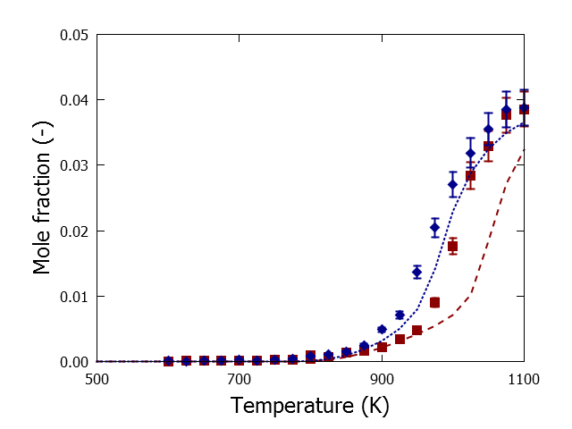

Fig. S 35 CO2 mole fractions as a function of temperature for prenol oxidation and pyrolysis in a jet-stirred reactor, P=0.107 MPa, FV =4.06 10-5 m3 s-1, xprenol,0=0.008, φ=0.5 (blue), φ=1.0 (red) and φ=∞ (black): symbols, experimental mole fraction profile; lines, mole fraction profiles calculated with CHEMKIN using the perfectly stirred reactor model and the developed kinetic model

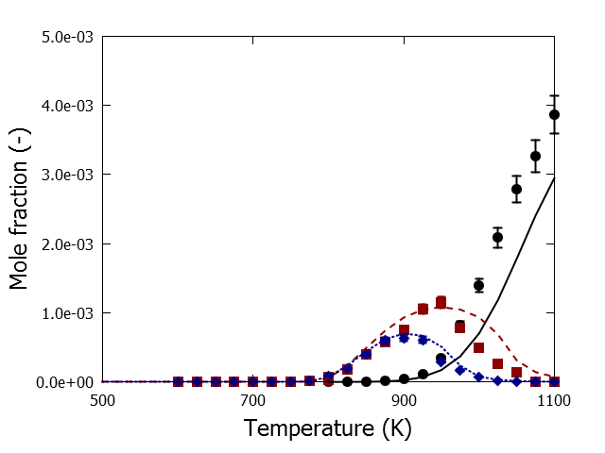

Fig. S 36 C2H4 mole fractions as a function of temperature for prenol oxidation and pyrolysis in a jet-stirred reactor, P=0.107 MPa, FV =4.06 10-5 m3 s-1, xprenol,0=0.008, φ=0.5 (blue), φ=1.0 (red) and φ=∞ (black): symbols, experimental mole fraction profile; lines, mole fraction profiles calculated with CHEMKIN using the perfectly stirred reactor model and the developed kinetic model

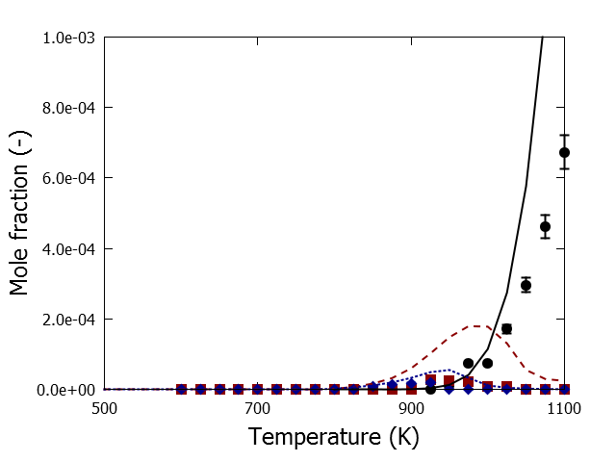

Fig. S 37 C2H2 mole fractions as a function of temperature for prenol oxidation and pyrolysis in a jet-stirred reactor, P=0.107 MPa, FV =4.06 10-5 m3 s-1, xprenol,0=0.008, φ=0.5 (blue), φ=1.0 (red) and φ=∞ (black): symbols, experimental mole fraction profile; lines, mole fraction profiles calculated with CHEMKIN using the perfectly stirred reactor model and the developed kinetic model

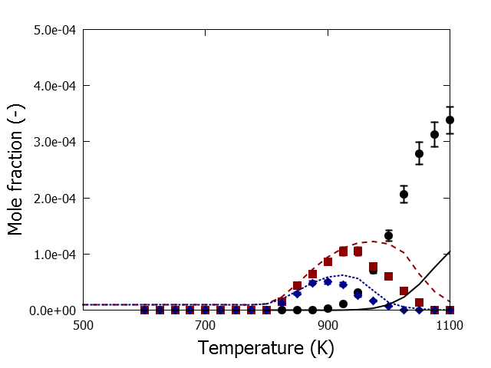

Fig. S 38 C2H6 mole fractions as a function of temperature for prenol oxidation and pyrolysis in a jet-stirred reactor, P=0.107 MPa, FV =4.06 10-5 m3 s-1, xprenol,0=0.008, φ=0.5 (blue), φ=1.0 (red) and φ=∞ (black): symbols, experimental mole fraction profile; lines, mole fraction profiles calculated with CHEMKIN using the perfectly stirred reactor model and the developed kinetic model

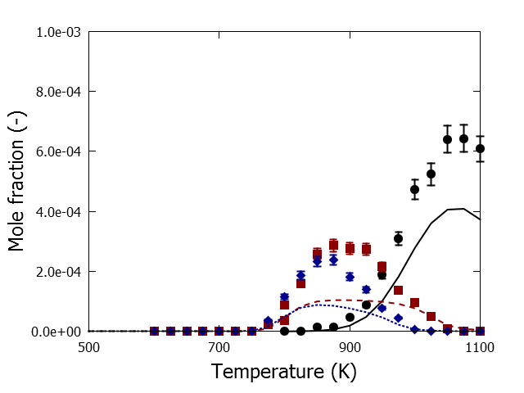

Fig. S 39 C3H6 mole fractions as a function of temperature for prenol oxidation and pyrolysis in a jet-stirred reactor, P=0.107 MPa, FV =4.06 10-5 m3 s-1, xprenol,0=0.008, φ=0.5 (blue), φ=1.0 (red) and φ=∞ (black): symbols, experimental mole fraction profile; lines, mole fraction profiles calculated with CHEMKIN using the perfectly stirred reactor model and the developed kinetic model

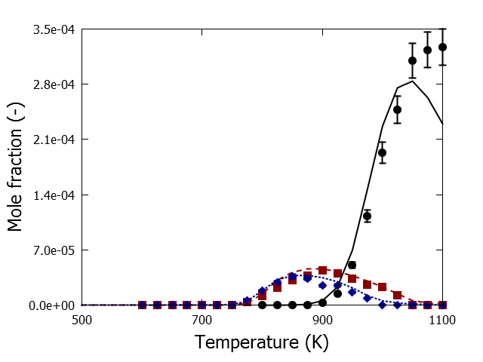

Fig. S 40 Allene mole fractions as a function of temperature for prenol oxidation and pyrolysis in a jet-stirred reactor, P=0.107 MPa, FV =4.06 10-5 m3 s-1, xprenol,0=0.008, φ=0.5 (blue), φ=1.0 (red) and φ=∞ (black): symbols, experimental mole fraction profile; lines, mole fraction profiles calculated with CHEMKIN using the perfectly stirred reactor model and the developed kinetic model

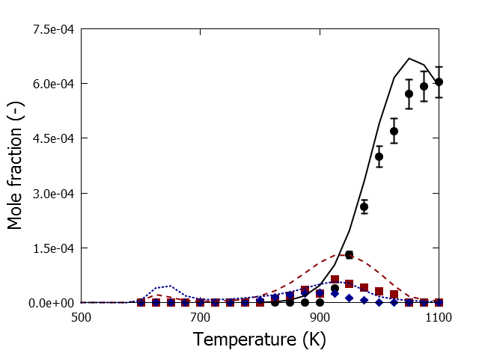

Fig. S 41 Propyne mole fractions as a function of temperature for prenol oxidation and pyrolysis in a jet-stirred reactor, P=0.107 MPa, FV =4.06 10-5 m3 s-1, xprenol,0=0.008, φ=0.5 (blue), φ=1.0 (red) and φ=∞ (black): symbols, experimental mole fraction profile; lines, mole fraction profiles calculated with CHEMKIN using the perfectly stirred reactor model and the developed kinetic model

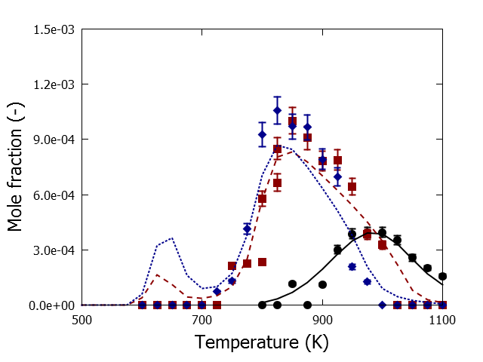

Fig. S 42 Formaldehyde mole fractions as a function of temperature for prenol oxidation and pyrolysis in a jet-stirred reactor, P=0.107 MPa, FV =4.06 10-5 m3 s-1, xprenol,0=0.008, φ=0.5 (blue), φ=1.0 (red) and φ=∞ (black): symbols, experimental mole fraction profile; lines, mole fraction profiles calculated with CHEMKIN using the perfectly stirred reactor model and the developed kinetic model

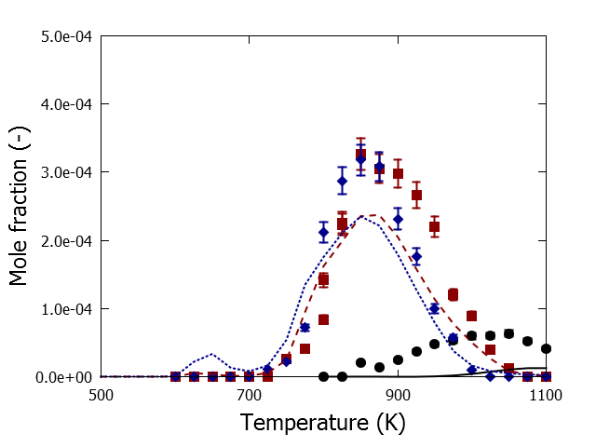

Fig. S 43 Acelaldehyde mole fractions as a function of temperature for prenol oxidation and pyrolysis in a jet-stirred reactor, P=0.107 MPa, FV =4.06 10-5 m3 s-1, xprenol,0=0.008, φ=0.5 (blue), φ=1.0 (red) and φ=∞ (black): symbols, experimental mole fraction profile; lines, mole fraction profiles calculated with CHEMKIN using the perfectly stirred reactor model and the developed kinetic model

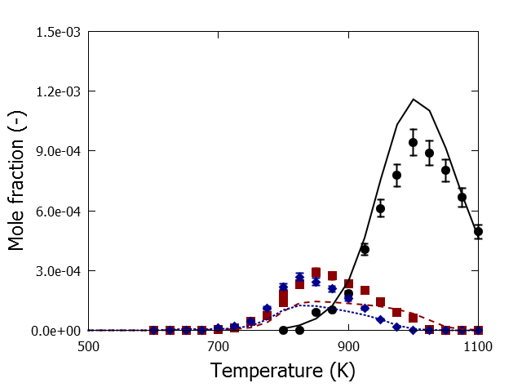

Fig. S 44 isobutene mole fractions as a function of temperature for prenol oxidation and pyrolysis in a jet-stirred reactor, P=0.107 MPa, FV =4.06 10-5 m3 s-1, xprenol,0=0.008, φ=0.5 (blue), φ=1.0 (red) and φ=∞ (black): symbols, experimental mole fraction profile; lines, mole fraction profiles calculated with CHEMKIN using the perfectly stirred reactor model and the developed kinetic model

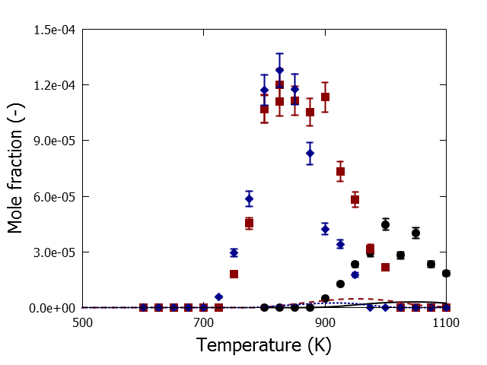

Fig. S 45 2-butene mole fractions as a function of temperature for prenol oxidation and pyrolysis in a jet-stirred reactor, P=0.107 MPa, FV =4.06 10-5 m3 s-1, xprenol,0=0.008, φ=0.5 (blue), φ=1.0 (red) and φ=∞ (black): symbols, experimental mole fraction profile; lines, mole fraction profiles calculated with CHEMKIN using the perfectly stirred reactor model and the developed kinetic model

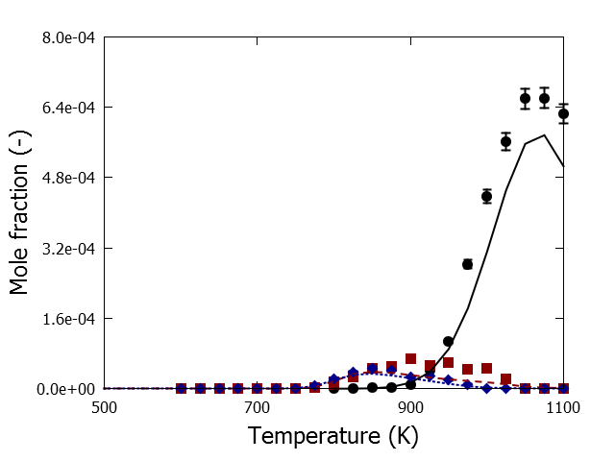

Fig. S 46 1,3-butadiene mole fractions as a function of temperature for prenol oxidation and pyrolysis in a jet-stirred reactor, P=0.107 MPa, FV =4.06 10-5 m3 s-1, xprenol,0=0.008, φ=0.5 (blue), φ=1.0 (red) and φ=∞ (black): symbols, experimental mole fraction profile; lines, mole fraction profiles calculated with CHEMKIN using the perfectly stirred reactor model and the developed kinetic model

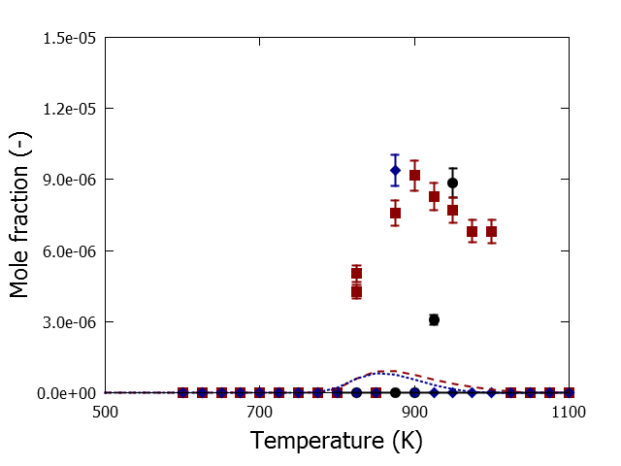

Fig. S 47 furan mole fractions as a function of temperature for prenol oxidation and pyrolysis in a jet-stirred reactor, P=0.107 MPa, FV =4.06 10-5 m3 s-1, xprenol,0=0.008, φ=0.5 (blue), φ=1.0 (red) and φ=∞ (black): symbols, experimental mole fraction profile; lines, mole fraction profiles calculated with CHEMKIN using the perfectly stirred reactor model and the developed kinetic model

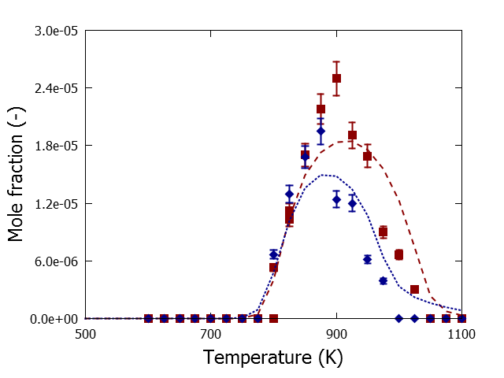

Fig. S 48 acrolein mole fractions as a function of temperature for prenol oxidation and pyrolysis in a jet-stirred reactor, P=0.107 MPa, FV =4.06 10-5 m3 s-1, xprenol,0=0.008, φ=0.5 (blue), φ=1.0 (red) and φ=∞ (black): symbols, experimental mole fraction profile; lines, mole fraction profiles calculated with CHEMKIN using the perfectly stirred reactor model and the developed kinetic model

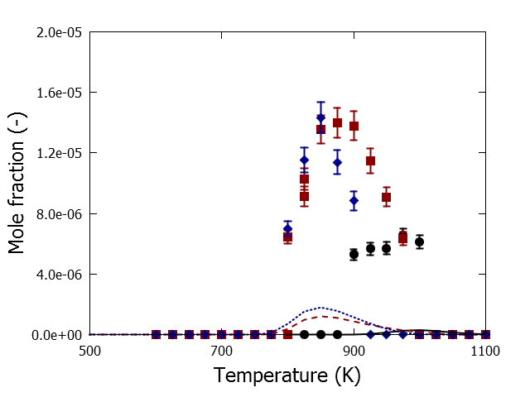

Fig. S 49 Propanal mole fractions as a function of temperature for prenol oxidation and pyrolysis in a jet-stirred reactor, P=0.107 MPa, FV =4.06 10-5 m3 s-1, xprenol,0=0.008, φ=0.5 (blue), φ=1.0 (red) and φ=∞ (black): symbols, experimental mole fraction profile; lines, mole fraction profiles calculated with CHEMKIN using the perfectly stirred reactor model and the developed kinetic model

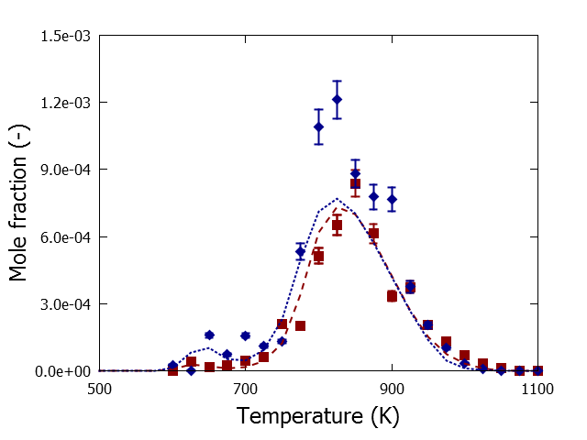

Fig. S 50 acetone mole fractions as a function of temperature for prenol oxidation and pyrolysis in a jet-stirred reactor, P=0.107 MPa, FV =4.06 10-5 m3 s-1, xprenol,0=0.008, φ=0.5 (blue), φ=1.0 (red) and φ=∞ (black): symbols, experimental mole fraction profile; lines, mole fraction profiles calculated with CHEMKIN using the perfectly stirred reactor model and the developed kinetic model

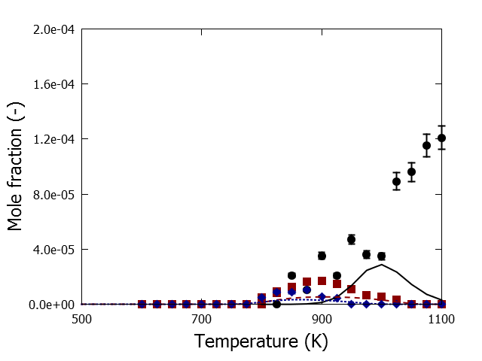

Fig. S 51 2-methyl-1-butene mole fractions as a function of temperature for prenol oxidation and pyrolysis in a jet-stirred reactor, P=0.107 MPa, FV =4.06 10-5 m3 s-1, xprenol,0=0.008, φ=0.5 (blue), φ=1.0 (red) and φ=∞ (black): symbols, experimental mole fraction profile; lines, mole fraction profiles calculated with CHEMKIN using the perfectly stirred reactor model and the developed kinetic model

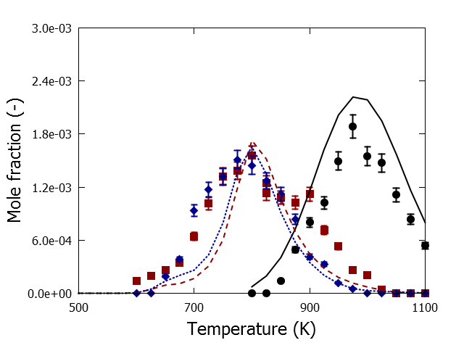

Fig. S 52 2-methyl-1,3-butadiene mole fractions as a function of temperature for prenol oxidation and pyrolysis in a jet-stirred reactor, P=0.107 MPa, FV =4.06 10-5 m3 s-1, xprenol,0=0.008, φ=0.5 (blue), φ=1.0 (red) and φ=∞ (black): symbols, experimental mole fraction profile; lines, mole fraction profiles calculated with CHEMKIN using the perfectly stirred reactor model and the developed kinetic model

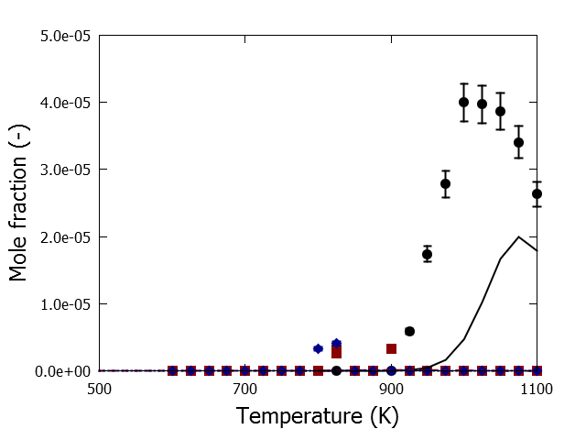

Fig. S 53 1,3-pentadiene mole fractions as a function of temperature for prenol oxidation and pyrolysis in a jet-stirred reactor, P=0.107 MPa, FV =4.06 10-5 m3 s-1, xprenol,0=0.008, φ=0.5 (blue), φ=1.0 (red) and φ=∞ (black): symbols, experimental mole fraction profile; lines, mole fraction profiles calculated with CHEMKIN using the perfectly stirred reactor model and the developed kinetic model

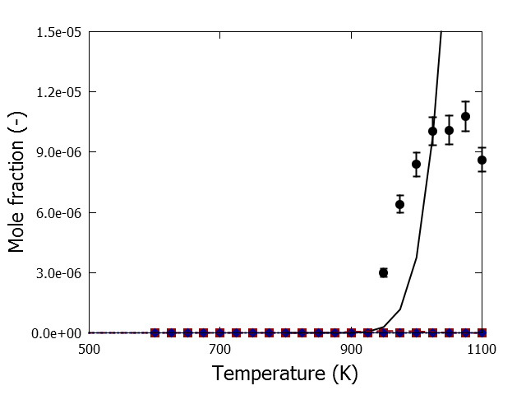

Fig. S 54 1,3-cyclopentadiene mole fractions as a function of temperature for prenol oxidation and pyrolysis in a jet-stirred reactor, P=0.107 MPa, FV =4.06 10-5 m3 s-1, xprenol,0=0.008, φ=0.5 (blue), φ=1.0 (red) and φ=∞ (black): symbols, experimental mole fraction profile; lines, mole fraction profiles calculated with CHEMKIN using the perfectly stirred reactor model and the developed kinetic model

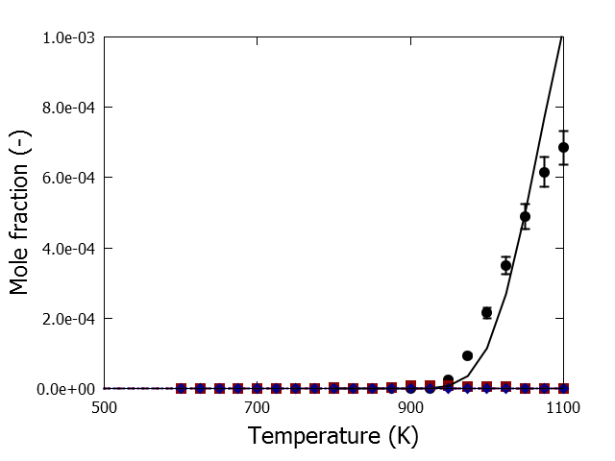

Fig. S 55 benzene mole fractions as a function of temperature for prenol oxidation and pyrolysis in a jet-stirred reactor, P=0.107 MPa, FV =4.06 10-5 m3 s-1, xprenol,0=0.008, φ=0.5 (blue), φ=1.0 (red) and φ=∞ (black): symbols, experimental mole fraction profile; lines, mole fraction profiles calculated with CHEMKIN using the perfectly stirred reactor model and the developed kinetic model

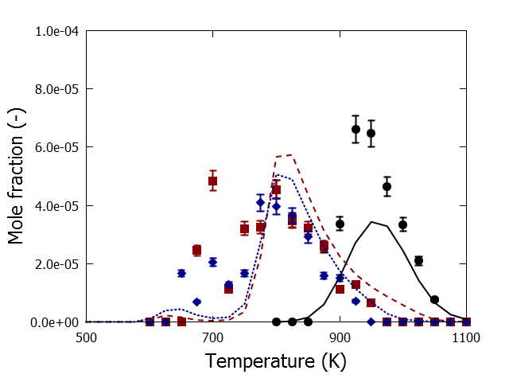

Fig. S 56 2-methyl-propanal mole fractions as a function of temperature for isoprenol oxidation and pyrolysis in a jet-stirred reactor, P=0.107 MPa, FV =4.06 10-5 m3 s-1, xisoprenol,0=0.008, φ=0.5 (blue), φ=1.0 (red) and φ=∞ (black): symbols, experimental mole fraction profile; lines, mole fraction profiles calculated with CHEMKIN using the perfectly stirred reactor model and the developed kinetic model

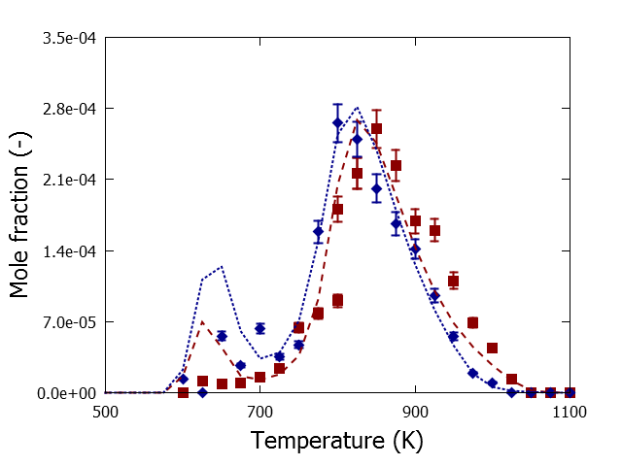

Fig. S 57 methacrolein mole fractions as a function of temperature for isoprenol oxidation and pyrolysis in a jet-stirred reactor, P=0.107 MPa, FV =4.06 10-5 m3 s-1, xisoprenol,0=0.008, φ=0.5 (blue), φ=1.0 (red) and φ=∞ (black): symbols, experimental mole fraction profile; lines, mole fraction profiles calculated with CHEMKIN using the perfectly stirred reactor model and the developed kinetic model

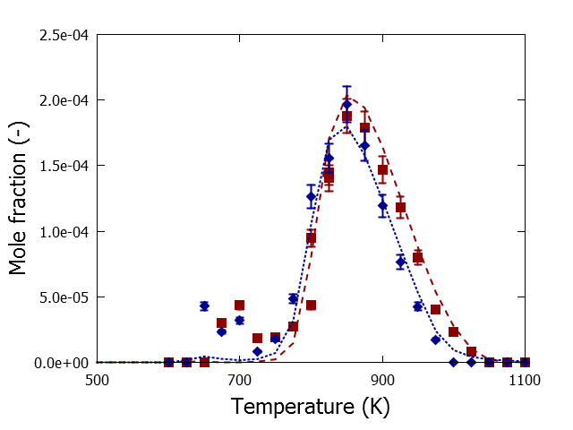

Fig. S 58 but-3-en-2-one mole fractions as a function of temperature for isoprenol oxidation and pyrolysis in a jet-stirred reactor, P=0.107 MPa, FV =4.06 10-5 m3 s-1, xisoprenol,0=0.008, φ=0.5 (blue), φ=1.0 (red) and φ=∞ (black): symbols, experimental mole fraction profile; lines, mole fraction profiles calculated with CHEMKIN using the perfectly stirred reactor model and the developed kinetic model

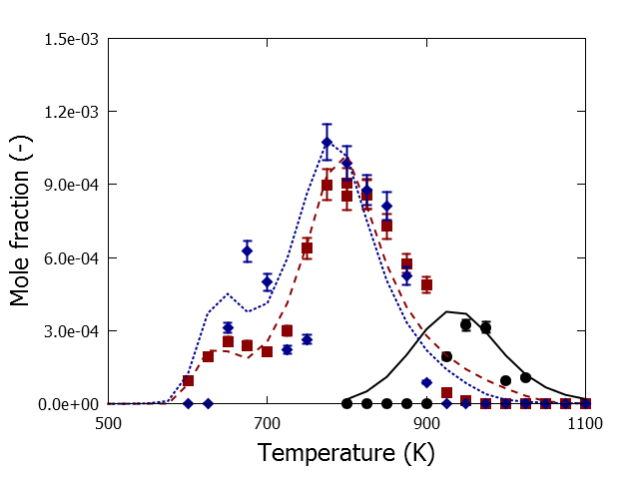

Fig. S 59 Prenal mole fractions as a function of temperature for isoprenol oxidation and pyrolysis in a jet-stirred reactor, P=0.107 MPa, FV =4.06 10-5 m3 s-1, xisoprenol,0=0.008, φ=0.5 (blue), φ=1.0 (red) and φ=∞ (black): symbols, experimental mole fraction profile; lines, mole fraction profiles calculated with CHEMKIN using the perfectly stirred reactor model and the developed kinetic model

**Species and transition state information from CBS-QB3 calculations**

The species and transition state are organized based on their appearance in Table 1of the main text. The radical site notated in the main text with a ‘•’ is represented by ‘J’ in the following list. If a distinction is made between cis and trans transition states, rate coefficients for each isomer are calculated that the overall rate expression is the sum of both (assuming that both are approximately of equal importance, hence of similar energy).

**Isoprenol**  **C=C(C)CCOH**

Geometry [Angstroms]

6 0.155731 -0.430050 0.091110

6 0.058706 -0.022589 1.544733

6 1.261951 0.290764 -0.679185

1 0.347703 -1.506996 0.014733

1 -0.790221 -0.234459 -0.419919

6 -0.958812 0.712664 1.994835

6 1.161796 -0.496446 2.459236

1 -1.032288 1.006831 3.036596

1 -1.756665 1.040182 1.336678

1 2.139822 -0.117056 2.144482

1 0.993294 -0.176908 3.489172

1 1.231907 -1.590161 2.446238

8 1.239108 -0.207855 -2.015239

1 1.075772 1.373520 -0.654589

1 2.238774 0.104881 -0.211728

1 1.916142 0.253676 -2.517988

Rotational Constants [GHz] = 1.599 1.840 7.131

Frequencies [cm-1]

44.1188 97.7605 176.3435

197.0601 267.7102 341.6938

403.2608 466.2012 539.0742

722.3127 809.0395 847.8323

927.6755 978.8450 998.4776

1020.1737 1050.8394 1076.1260

1101.9467 1222.9518 1242.8540

1291.1323 1318.5790 1341.4192

1412.2537 1445.3906 1453.4183

1480.1814 1491.0833 1500.9836

1529.0244 1712.1541 2973.4226

3001.3821 3013.5015 3022.8738

3057.6560 3079.7671 3102.7300

3125.8608 3205.2688 3839.9419

**C2C=C**

Geometry [Angstroms]

6 -0.008006 -0.152524 -0.004816

6 0.013390 0.015758 1.492959

6 1.377980 -0.006393 2.132903

6 -1.102088 0.173837 2.205392

1 0.450708 -1.104144 -0.297712

1 -1.024466 -0.126591 -0.401462

1 0.572235 0.637816 -0.495184

1 -1.075924 0.294135 3.283236

1 -2.079633 0.188352 1.735185

1 2.012689 0.790201 1.727486

1 1.320447 0.119900 3.215458

1 1.892084 -0.951895 1.924326

Rotational Constants [GHz] = 4.620 8.368 9.153

Frequencies [cm-1]

168.4944 208.1867 380.5237

439.1494 440.9440 704.9992

813.6941 918.5160 960.5673

983.8539 1021.5856 1083.2653

1105.7559 1293.1761 1409.8623

1413.5787 1442.2336 1472.3876

1485.6305 1490.3470 1502.7919

1719.0052 3005.9309 3011.6887

3049.0374 3052.1636 3101.8828

3103.6863 3126.4939 3205.4385

**CH2O**

Geometry [Angstroms]

6 -0.000086 0.525856 0.000000

1 0.938496 1.118323 0.000000

8 -0.000025 -0.674081 0.000000

1 -0.938728 1.118228 0.000000

Rotational Constants [GHz] = 34.335 39.046 284.593

Frequencies [cm-1]

1202.1785 1270.1422 1539.1178

1827.0549 2869.5789 2918.8086

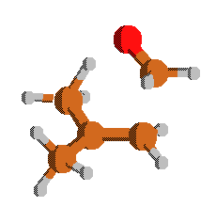**Rxn1**

**TS C=C(C)CCOH => C2C=C+CH2O**

Geometry [Angstroms]

6 0.085237 0.013737 -0.037664

6 0.013966 -0.020054 1.380127

6 1.279875 -0.043237 2.191034

6 -1.201526 -0.427453 1.947556

6 -1.183523 -2.270278 1.387063

8 -0.865659 -2.370561 0.141916

1 -1.284743 -0.469308 3.029783

1 -2.112122 -0.122972 1.441072

1 1.046124 0.253178 -0.487820

1 -0.762572 0.447267 -0.565194

1 1.121359 -0.447994 3.192170

1 2.058761 -0.627317 1.691536

1 1.667035 0.976189 2.297441

1 -0.493530 -2.686149 2.139894

1 -2.238602 -2.428094 1.649495

1 -0.195466 -1.221248 -0.171983

Rotational Constants [GHz] = 2.311 2.679 5.074

Frequencies [cm-1]

-1137.5406 76.1114 136.2534

176.0563 368.8711 405.0896

453.6654 497.6875 574.5224

596.7416 667.0401 824.2939

892.7602 937.7783 988.9911

1020.2337 1059.6075 1062.5592

1077.6581 1085.0446 1214.9930

1240.3469 1325.2452 1366.0004

1403.5094 1417.3958 1430.0083

1479.6650 1487.3527 1528.3698

1556.2013 1573.3467 1649.5830

2928.2368 2993.5930 3021.0835

3071.4861 3090.8455 3107.3157

3112.2393 3164.7395 3189.3174

**C=C(C)CCJOH**

Geometry [Angstroms]

6 0.020979 0.050604 -0.028553

6 -0.029061 0.016301 1.303084

6 1.211289 -0.061390 2.155557

6 -1.349343 0.050363 2.046316

6 -1.652885 -1.237431 2.738653

8 -2.640385 -1.149314 3.690611

1 -1.329863 0.842596 2.806754

1 -2.157590 0.317193 1.346429

1 0.964538 0.022726 -0.563317

1 -0.880472 0.113270 -0.629076

1 1.175651 -0.933368 2.816408

1 2.115888 -0.120157 1.547616

1 1.289255 0.818875 2.804400

1 -1.567213 -2.178946 2.198454

1 -2.834190 -2.030763 4.023314

Rotational Constants [GHz] = 1.646 1.899 7.306

Frequencies [cm-1]

72.9856 82.6046 179.7092

196.8562 345.9027 368.1214

396.1781 462.0801 538.2463

599.5846 724.9664 832.2096

925.2889 936.1967 979.2075

1029.0670 1042.2557 1068.0793

1174.3070 1189.7303 1244.4667

1292.2725 1338.7604 1408.3707

1440.5272 1444.6333 1470.3212

1479.8727 1497.3625 1714.3000

2943.9617 3009.5586 3014.3174

3060.1548 3103.8784 3108.6260

3125.6938 3204.9734 3841.8872

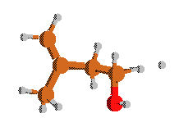**Rxn9**

**TS H+C=C(C)CCOH => H2+C=C(C)CCJOH**

Geometry [Angstroms]

6 -0.016517 0.035602 0.008676

6 -0.002052 0.005575 1.342640

6 1.308700 0.007052 2.106636

6 1.660201 1.347392 2.730231

8 0.841999 1.629522 3.830256

6 -1.265848 -0.028863 2.162207

1 1.282941 -0.739015 2.909348

1 2.126487 -0.267415 1.434175

1 -0.947089 0.044897 -0.548852

1 0.900323 0.046163 -0.571771

1 -1.294776 0.805946 2.866908

1 -2.154542 0.004224 1.529023

1 -1.306183 -0.943707 2.764894

1 2.830926 1.250424 3.104512

1 1.682025 2.160490 1.993357

1 0.998533 2.536631 4.111127

1 3.874426 1.141460 3.416032

Rotational Constants [GHz] = 1.819 2.292 5.350

Frequencies [cm-1]

-823.7136 51.9530 123.9881

196.0791 196.5110 281.9335

340.6296 347.1141 378.1954

423.7589 447.3453 570.3415

724.8404 803.2413 885.8864

921.3110 943.0761 999.1075

1036.2770 1063.1970 1093.1907

1121.9939 1190.7153 1241.1187

1285.4913 1301.6486 1346.7985

1354.0668 1400.8756 1412.7375

1443.7656 1446.5317 1468.8071

1481.0535 1501.0791 1705.8245

3010.2029 3017.2278 3026.6782

3073.7847 3075.5068 3108.9211

3124.8962 3203.9858 3830.7339



**t-C=C(C)CJCOH or t-C2JC=CCOH**

Geometry [Angstroms]

6 -0.000317 0.001936 0.002997

6 -0.002188 -0.000911 1.386675

6 1.324700 0.006545 2.124497

6 -1.208536 -0.018394 2.092039

6 -1.381564 -0.034714 3.574928

8 -2.391818 0.884499 4.008155

1 -2.135852 -0.032805 1.524592

1 0.922874 0.014962 -0.562927

1 -0.928614 -0.010222 -0.556316

1 1.453493 -0.896447 2.727796

1 2.157999 0.059596 1.422499

1 1.403630 0.862543 2.800937

1 -1.740922 -1.014825 3.911217

1 -0.433093 0.153837 4.093140

1 -2.156733 1.749171 3.655350

Rotational Constants [GHz] = 1.618 1.921 7.231

Frequencies [cm-1]

57.5540 139.9527 142.5146

236.6491 358.2362 376.5610

466.3723 492.4262 516.6029

566.3114 746.7213 798.1607

837.4494 923.4803 996.2976

1020.7852 1034.0576 1056.3759

1139.9290 1195.6840 1270.7084

1349.2839 1378.9615 1407.3309

1419.7638 1463.7841 1487.7614

1500.0011 1503.5507 1518.1605

2998.6238 3025.7053 3031.4343

3080.6018 3109.2231 3135.9758

3142.7141 3230.6775 3813.6299

**c-C=C(C)CJCOH or c-C2JC=CCOH**

Geometry [Angstroms]

6 0.003418 -0.010095 0.001055

6 0.004533 -0.000366 1.384973

6 1.166746 0.002087 2.161077

6 2.580232 -0.021227 1.676736

8 3.411032 0.881580 2.414883

6 -1.328138 -0.020751 2.114572

1 1.066485 0.007016 3.243665

1 -0.927519 -0.006019 -0.552334

1 0.916078 -0.020817 -0.580040

1 -1.295432 0.594715 3.016660

1 -2.135342 0.348989 1.479425

1 -1.586285 -1.039262 2.421305

1 3.025876 -1.008608 1.843793

1 2.644472 0.182135 0.601158

1 3.015302 1.756103 2.338808

Rotational Constants [GHz] = 1.580 1.852 7.595

Frequencies [cm-1]

45.9276 57.5740 136.4569

241.3355 354.6352 379.4326

458.2051 489.8037 514.1468

555.1449 730.4854 790.7422

856.2278 928.3252 1001.8546

1026.1534 1053.5623 1058.8320

1121.0474 1194.5865 1257.4919

1341.7927 1355.2186 1406.2581

1412.1947 1478.0868 1492.9022

1494.0288 1496.6945 1533.7914

3004.6233 3028.2878 3034.8657

3083.8259 3106.0012 3140.3774

3149.3054 3236.4514 3815.9084

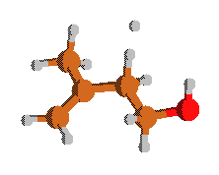**Rxn10 (cis)**

**TS H+c-C=C(C)CCOH => H2+c-C=C(C)CJCOH**

Geometry [Angstroms]

6 -0.000816 0.119627 0.015775

6 0.005133 0.012170 1.350666

6 1.245706 0.048174 2.170462

6 2.548284 0.449163 1.515917

8 3.546645 0.455654 2.532022

6 -1.267988 -0.200203 2.131309

1 1.108258 0.601962 3.103952

1 1.420358 -1.088020 2.593352

1 -0.927775 0.072738 -0.544841

1 0.903963 0.263195 -0.562604

1 -1.426469 0.609933 2.851352

1 -2.138652 -0.252352 1.475659

1 -1.215964 -1.130523 2.708315

1 2.803630 -0.256513 0.713672

1 2.437229 1.446708 1.064048

1 4.391617 0.655909 2.120166

1 1.593948 -2.108276 2.956336

Rotational Constants [GHz] = 1.503 1.781 7.057

Frequencies [cm-1]

-832.5806 78.9009 119.2387

179.3549 189.1961 247.2498

297.6072 341.8155 364.5472

434.1057 503.4662 509.6005

693.4592 846.3409 876.2566

918.0674 978.2810 1008.2308

1033.7837 1059.5908 1079.2913

1097.0568 1170.4377 1241.3351

1281.0201 1328.2679 1352.4003

1398.9282 1412.4813 1424.0000

1447.1707 1475.6506 1483.4563

1497.3044 1511.3463 1685.5758

2995.7205 3014.0569 3053.5400

3060.0647 3067.1494 3106.8135

3139.4604 3219.4890 3820.3494

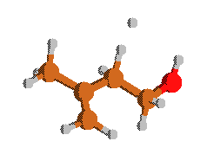

**Rxn10 (trans)**

**TS H+t-C=C(C)CCOH => H2+t-C=C(C)CJCOH**

Geometry [Angstroms]

6 0.001781 0.004859 0.003035

6 0.000108 0.002722 1.342011

6 1.283227 -0.007438 2.135115

6 -1.247411 0.037930 2.155787

6 -2.594115 -0.136572 1.470942

8 -3.665967 -0.136122 2.406158

1 -1.185303 -0.617609 3.030255

1 -1.292538 1.128856 2.677836

1 0.932001 -0.015488 -0.553905

1 -0.909368 0.018227 -0.582464

1 1.336578 -0.889283 2.782681

1 2.158819 -0.006317 1.483944

1 1.341303 0.869807 2.789490

1 -2.739535 0.634647 0.703215

1 -2.634227 -1.108796 0.971855

1 -3.698361 0.734611 2.815517

1 -1.449825 2.148263 3.161147

Rotational Constants [GHz] = 1.492 1.760 7.045

Frequencies [cm-1]

-832.5806 78.9009 119.2387

179.3549 189.1961 247.2498

297.6072 341.8155 364.5472

434.1057 503.4662 509.6005

693.4592 846.3409 876.2566

918.0674 978.2810 1008.2308

1033.7837 1059.5908 1079.2913

1097.0568 1170.4377 1241.3351

1281.0201 1328.2679 1352.4003

1398.9282 1412.4813 1424.0000

1447.1707 1475.6506 1483.4563

1497.3044 1511.3463 1685.5758

2995.7205 3014.0569 3053.5400

3060.0647 3067.1494 3106.8135

3139.4604 3219.4890 3820.3494

**C=C(CJ)CCOH**

Geometry [Angstroms]

6 -0.065373 -0.174412 0.017339

6 0.068459 -0.045629 1.392773

6 1.314746 -0.012172 2.002663

6 -1.180509 0.023521 2.255381

6 -1.653778 -1.359344 2.697065

8 -2.821531 -1.178787 3.494136

1 -0.993525 0.622741 3.150434

1 -1.995642 0.505234 1.708881

1 0.804014 -0.256446 -0.624620

1 -1.039213 -0.186030 -0.457023

1 1.416146 0.102625 3.075071

1 2.225472 -0.089361 1.420178

1 -1.866742 -1.974998 1.811606

1 -0.855488 -1.856470 3.266292

1 -3.127237 -2.045130 3.777253

Rotational Constants [GHz] = 1.658 1.877 7.645

Frequencies [cm-1]

46.5519 104.3099 190.4382

265.6180 349.0249 410.3537

471.0588 542.2573 555.3006

590.8330 772.2262 804.0503

816.1638 893.1970 978.1213

1015.1238 1045.7444 1056.3256

1061.8882 1211.4232 1242.7898

1308.3221 1322.3635 1356.0909

1384.6128 1452.9115 1487.7354

1501.1820 1528.0485 1529.1895

2969.8284 2999.7661 3045.1868

3087.5117 3132.8982 3140.3921

3228.2668 3230.4014 3839.9685

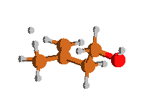

**Rxn11**

**TS H+C=C(C)CCOH => H2+C=C(CJ)CCOH**

Geometry [Angstroms]

6 0.042408 -0.046598 0.016541

6 -0.014398 0.004736 1.355197

6 1.220295 0.027369 2.173295

6 -1.338348 0.020429 2.087520

6 -1.608258 -1.244111 2.901074

8 -2.881953 -1.077039 3.520310

1 -1.372920 0.872425 2.776774

1 -2.159317 0.147598 1.377884

1 0.989615 -0.056617 -0.512071

1 -0.857382 -0.069260 -0.588063

1 1.467298 -1.103014 2.615694

1 2.124348 0.268811 1.614926

1 1.147786 0.619531 3.087465

1 -1.600767 -2.116902 2.233203

1 -0.823393 -1.391171 3.654922

1 -3.067421 -1.865311 4.038379

1 1.767145 -2.048285 3.021523

Rotational Constants [GHz] = 1.566 1.819 6.358

Frequencies [cm-1]

-1162.4744 69.0698 99.3308

156.9161 187.9647 271.3428

308.4507 343.2193 408.2193

466.6709 558.4828 590.3397

706.1461 813.7107 860.1820

922.1877 984.2633 1012.2206

1022.0245 1042.3258 1067.1417

1099.7559 1224.1909 1243.7115

1280.9579 1303.9214 1319.6716

1336.7922 1338.4858 1393.7819

1444.6893 1459.5770 1471.7988

1497.8110 1529.0931 1671.4008

2976.5298 3007.3767 3024.1089

3065.7146 3082.7737 3130.2129

3139.5950 3213.3022 3840.2881

**Prenol CC(C)=CCOH**

Geometry [Angstroms]

6 -0.002685 0.002717 0.001000

6 -0.003898 0.000060 1.509463

6 1.370721 -0.004807 2.131921

6 -1.101806 0.015443 2.276263

6 -2.540043 0.007644 1.849719

8 -3.277517 -1.035412 2.498216

1 -0.973408 0.016548 3.357396

1 0.593555 -0.833053 -0.382425

1 -0.999497 -0.062706 -0.433680

1 0.466305 0.918014 -0.378489

1 1.945901 0.874282 1.818183

1 1.322714 -0.009069 3.222197

1 1.942568 -0.882773 1.809022

1 -3.032546 0.932893 2.164037

1 -2.645053 -0.061902 0.760823

1 -2.816026 -1.860433 2.315725

Rotational Constants [GHz] = 1.580 1.851 6.823

Frequencies [cm-1]

69.1736 139.5620 152.4776

205.9689 269.7759 360.6302

369.2916 433.0363 501.1512

512.9534 786.9810 868.4107

956.3680 963.6875 1015.4524

1028.4303 1054.1108 1101.9493

1131.0146 1189.6023 1240.2190

1337.0114 1381.6655 1410.5428

1419.0396 1423.3737 1473.4189

1484.7673 1492.9370 1495.6108

1509.1342 1729.7607 3006.1414

3009.7981 3015.7830 3047.8479

3052.5449 3053.7900 3102.9519

3120.8381 3122.3040 3817.5969

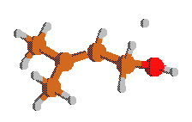**Rxn12**

**TS H+CC(C)=CCOH => H2+CC(C)=CCJOH**

Geometry [Angstroms]

6 -0.008956 0.025142 -0.002177

6 -0.002580 -0.002096 1.505160

6 1.100457 -0.022114 2.263067

6 2.521551 -0.039879 1.814733

8 3.284929 0.766293 2.701185

6 -1.371053 -0.017659 2.138545

1 0.992746 -0.052842 3.344708

1 -0.634340 0.847494 -0.367273

1 0.984391 0.135984 -0.436527

1 -0.444981 -0.898609 -0.400439

1 -1.946365 -0.890929 1.808666

1 -1.313718 -0.039003 3.228054

1 -1.947529 0.866378 1.841791

1 2.905931 -1.107092 1.850860

1 2.639527 0.283789 0.773442

1 4.213215 0.666733 2.469184

1 3.601245 -2.436911 1.853660

Rotational Constants [GHz] = 1.512 1.753 6.353

Frequencies [cm-1]

-212.5800 60.2673 129.1004

142.0272 162.3706 190.5613

212.3524 277.4211 312.5138

359.0831 435.6603 488.3205

515.3175 799.7411 855.6188

960.6371 988.3128 1013.9152

1048.2000 1063.4613 1102.0195

1122.4301 1209.0138 1237.1227

1275.0880 1356.0585 1410.7764

1420.2162 1445.2738 1462.9572

1473.8990 1486.7144 1492.8582

1497.1589 1727.7181 2374.5461

3005.8955 3008.7439 3014.9656

3047.5195 3053.0830 3104.4746

3117.2847 3137.7871 3830.9521

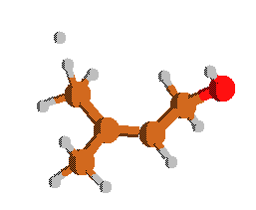**Rxn13 (cis)**

**TS H+C2C=CCOH => H2+c-C2JC=CCOH**

**aka H+CC(C)=CCOH => H2+c-C=C(C)CJCOH**

Geometry [Angstroms]

6 0.035494 0.093807 0.038238

6 0.031490 0.081819 1.517867

6 1.398256 0.103215 2.158495

6 -1.080746 0.015574 2.274175

6 -2.509149 -0.056683 1.823074

8 -3.191820 -1.163572 2.421834

1 -0.965735 -0.005938 3.356018

1 0.394136 -1.021133 -0.363285

1 -0.924563 0.249848 -0.447803

1 0.800139 0.740890 -0.395261

1 1.944782 1.013684 1.888960

1 1.336270 0.050493 3.246537

1 2.001302 -0.742252 1.807193

1 -3.057329 0.826773 2.164521

1 -2.594933 -0.092086 0.731209

1 -2.694932 -1.957446 2.197946

1 0.703645 -1.972977 -0.759278

Rotational Constants [GHz] = 1.558 1.803 6.105

Frequencies [cm-1]

-1141.3152 62.6317 114.2666

150.6073 193.0325 263.0024

277.5575 370.5097 373.2171

455.7042 497.3857 544.0728

563.0683 796.9488 870.8786

960.1698 979.3404 1021.6866

1031.0479 1056.9825 1094.2156

1130.5520 1190.6766 1245.4677

1288.5734 1327.3810 1340.2142

1369.0354 1395.1384 1414.8209

1421.4115 1472.6342 1484.5254

1495.7841 1506.0529 1687.4681

3011.3721 3014.2437 3054.7422

3055.7896 3075.6726 3106.9827

3129.8955 3155.7000 3816.4507

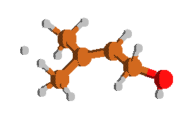**Rxn13 (trans)**

**TS H+C2C=CCOH => H2+t-C2JC=CCOH**

**aka H+CC(C)=CCOH => H2+t-C=C(C)CJCOH**

Geometry [Angstroms]

6 0.005163 -0.004805 0.000886

6 0.003524 -0.005376 1.479995

6 1.116923 -0.002410 2.237936

6 2.546313 0.047980 1.789401

8 3.282357 1.058691 2.486010

6 -1.362440 -0.075658 2.119092

1 1.003486 -0.020677 3.320060

1 -0.206254 -1.154997 -0.399264

1 -0.829651 0.542332 -0.440907

1 0.945257 0.259875 -0.478940

1 -1.891341 -0.981757 1.801290

1 -1.299708 -0.083167 3.208383

1 -1.982618 0.774591 1.814459

1 3.051774 -0.889562 2.041099

1 2.632296 0.179117 0.704270

1 2.824008 1.893021 2.341858

1 -0.390896 -2.135732 -0.807405

Rotational Constants [GHz] = 1.521 1.788 6.257

Frequencies [cm-1]

-1145.0885 66.2875 108.9368

154.7348 193.3356 264.8337

276.0446 364.5743 372.9910

470.3051 496.5683 532.5198

564.2199 800.1082 869.1586

959.8280 980.9665 1019.9458

1031.3856 1055.4670 1091.1089

1130.3292 1191.1219 1241.6637

1288.6967 1329.2642 1341.3658

1370.6785 1396.7314 1414.5265

1420.2582 1471.3662 1484.4294

1495.2407 1504.1740 1685.6786

3009.6326 3011.5518 3052.7317

3055.7778 3070.8398 3106.5913

3129.3733 3148.7158 3817.9880

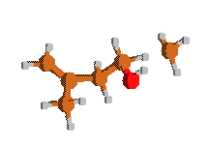**Rxn14**

**TS CH3+C=C(C)CCOH => CH4+C=C(C)CCJOH**

Geometry [Angstroms]

6 0.035054 -0.030605 -0.028140

6 0.017065 -0.007653 1.306077

6 1.279912 0.015309 2.127662

6 -1.294471 -0.008253 2.069359

6 -1.644532 -1.338850 2.711514

8 -0.826443 -1.596919 3.824771

1 -1.270861 0.750234 2.861234

1 -2.110360 0.256874 1.390320

1 0.966891 -0.043070 -0.583677

1 -0.880550 -0.033778 -0.610765

1 1.301224 -0.822065 2.829470

1 2.169640 -0.020875 1.495878

1 1.325061 0.927392 2.734372

1 -2.857916 -1.244361 3.103500

1 -1.650344 -2.166018 1.989805

1 -0.994659 -2.494294 4.128294

6 -4.238117 -1.119471 3.561652

1 -4.457863 -2.081041 4.019395

1 -4.202909 -0.291324 4.264608

1 -4.812109 -0.916791 2.661090

Rotational Constants [GHz] = 1.034 1.252 3.903

Frequencies [cm-1]

-1447.1787 26.5918 40.4756

75.9311 92.8286 172.0178

200.6977 231.7686 320.6583

335.3832 418.2033 429.1901

470.0835 522.2327 542.9154

624.5928 728.3443 814.4816

885.9209 916.5557 948.6713

996.3028 1039.0723 1064.9526

1101.8362 1110.3318 1117.3096

1191.8947 1284.0490 1311.5653

1321.8289 1375.7365 1412.2146

1416.7021 1427.3918 1444.8717

1453.7968 1465.1982 1469.7417

1480.6077 1501.0293 1704.8669

3003.1492 3015.3586 3020.0520

3056.4956 3068.4575 3073.8015

3108.1587 3123.4712 3188.8071

3194.1772 3202.0913 3833.3757

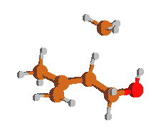**Rxn15 (cis)**

**TS CH3+C=C(C)CCOH => CH4+c-C=C(C)CJCOH**

Geometry [Angstroms]

6 0.012671 0.108866 0.015879

6 0.002914 0.002356 1.353387

6 1.288594 -0.109135 2.137535

6 -1.237390 0.018335 2.166080

6 -2.576301 -0.213279 1.486997

8 -3.653147 -0.209564 2.420085

1 -1.156623 -0.604689 3.061707

1 -1.329336 1.169654 2.676268

1 0.945020 0.109615 -0.537816

1 -0.894805 0.190926 -0.569791

1 1.325701 -1.052472 2.693184

1 2.163386 -0.060418 1.486798

1 1.366775 0.695644 2.877039

1 -2.743905 0.529327 0.695312

1 -2.595240 -1.200396 1.015734

1 -3.694438 0.667436 2.813597

6 -1.551778 2.526985 3.261773

1 -0.541783 2.923852 3.299461

1 -2.199508 3.017961 2.540332

1 -1.999991 2.337948 4.233183

Rotational Constants [GHz] = 1.186 1.518 2.768

Frequencies [cm-1]

-1387.4681 52.4990 53.1672

84.2558 117.9812 157.1059

174.6032 191.7132 313.8273

357.4158 412.6235 438.9449

466.4753 520.4772 531.3643

588.7755 708.8685 879.0230

883.6291 901.8085 976.9924

1010.5614 1034.2632 1059.7747

1083.0890 1091.1787 1116.4427

1196.2343 1250.0995 1329.9308

1361.5741 1400.4993 1406.2395

1411.7177 1425.1750 1436.3167

1438.7737 1447.4794 1482.8260

1496.5573 1510.3207 1668.9363

2988.8679 3014.2119 3054.2908

3059.2090 3061.6575 3064.0164

3104.4607 3138.4883 3200.2925

3205.4563 3218.1614 3829.8950

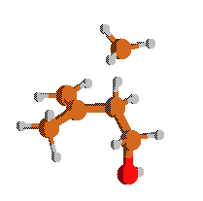**Rxn15 (trans)**

**TS CH3+C=C(C)CCOH => CH4+t-C=C(C)CJCOH**

Geometry [Angstroms]

6 -0.007631 0.006680 0.000430

6 0.006045 -0.004287 2.751007

6 1.485863 0.002762 3.103500

8 1.734971 0.095171 4.507747

6 -0.832424 1.118689 3.243801

6 -0.219549 2.497033 3.244725

6 -2.098076 0.913347 3.636864

1 -0.458190 -0.973850 2.957374

1 -0.004075 0.029231 1.486544

1 -2.731412 1.730334 3.964571

1 -2.535821 -0.079486 3.643913

1 0.155909 2.764594 2.250473

1 -0.945945 3.252570 3.548166

1 0.628935 2.535317 3.933919

1 1.963045 -0.891469 2.680001

1 1.984768 0.871569 2.668793

1 1.219415 -0.591218 4.943596

1 0.716034 0.766909 -0.278947

1 0.280772 -1.010933 -0.246149

1 -1.041987 0.256280 -0.216210

Rotational Constants [GHz] = 1.303 1.929 2.092

Frequencies [cm-1]

-1404.2079 28.7730 65.7001

84.4571 100.2164 131.4187

212.8106 251.5082 303.5403

359.6564 406.4609 441.2936

460.8418 530.5118 548.4595

629.1119 722.8731 779.7375

900.2161 937.3021 950.4903

1001.6168 1031.1779 1064.0181

1071.2107 1083.4899 1109.3397

1199.5969 1302.1849 1311.7627

1359.8198 1387.4705 1404.5262

1408.4235 1425.2156 1430.0240

1431.3904 1451.4874 1485.4106

1499.3420 1517.6295 1668.9624

2990.3113 3017.4880 3047.3274

3064.4031 3072.0657 3081.5359

3108.1365 3126.6013 3205.7205

3207.9790 3208.9619 3819.8491

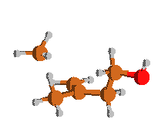

**Rxn16**

**TS CH3+C=C(C)CCOH => CH4+C=C(CJ)CCOH**

Geometry [Angstroms]

6 0.027739 0.072579 0.004949

6 0.017371 0.012086 1.346385

6 1.310397 -0.027968 2.133282

6 1.575352 1.233694 2.951961

8 2.811956 1.039460 3.636143

6 -1.248066 0.010864 2.110190

1 1.297240 -0.876309 2.827656

1 2.157479 -0.177351 1.459392

1 -0.892500 0.095319 -0.569268

1 0.956113 0.089252 -0.554974

1 -1.550512 1.185473 2.486988

1 -2.121160 -0.275984 1.524033

1 -1.207897 -0.538031 3.052815

1 1.624996 2.101908 2.279746

1 0.758077 1.405029 3.665200

1 2.997850 1.831849 4.147661

6 -2.021422 2.513269 2.905786

1 -1.429922 3.177473 2.282260

1 -3.081898 2.494765 2.671929

1 -1.792099 2.555538 3.966760

Rotational Constants [GHz] = 1.073 1.533 2.456

Frequencies [cm-1]

-1503.4293 37.5180 56.5196

67.4033 100.7492 106.6329

197.6121 269.6524 339.1519

361.7858 400.6934 445.3880

490.9932 509.7430 630.2395

695.6303 713.4717 815.3516

868.8272 906.1958 984.9835

1022.9601 1023.8509 1056.1482

1077.8604 1097.0618 1115.4707

1224.4868 1242.3851 1301.5345

1319.9495 1340.0717 1393.7087

1404.8423 1431.3748 1435.5491

1443.1523 1455.9092 1473.0175

1498.0376 1528.4709 1659.8090

2974.9902 3006.9685 3024.0254

3062.5547 3063.0332 3081.3584

3128.1431 3133.8079 3203.6675

3205.4841 3210.7996 3840.1335

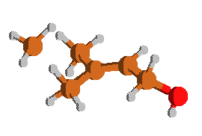

**Rxn17 (cis)**

**TS CH3+CC(C)=CCOH => CH4+c-C=C(C)CJCOH**

Geometry [Angstroms]

6 0.000805 0.024895 -0.006655

6 -0.020118 0.036775 1.468893

6 1.079825 -0.007167 2.248243

6 2.515604 -0.011164 1.819605

8 3.279247 0.980341 2.516802

6 -1.395950 0.032177 2.093703

1 0.948217 -0.021253 3.328358

1 -0.200036 -1.159210 -0.418342

1 -0.827556 0.569035 -0.463907

1 0.947840 0.290335 -0.473176

1 -1.967551 -0.845317 1.770259

1 -1.345846 0.021375 3.183792

1 -1.969039 0.913071 1.783641

1 2.988663 -0.962320 2.083804

1 2.617955 0.109513 0.734445

1 2.837569 1.824274 2.376342

6 -0.401154 -2.510159 -0.960318

1 0.184054 -3.123657 -0.281455

1 -1.475385 -2.658586 -0.899151

1 -0.008406 -2.443530 -1.970770

Rotational Constants [GHz] = 0.973 1.212 3.082

Frequencies [cm-1]

-1482.8964 22.5035 41.1333

59.7657 102.7945 147.7469

187.4684 264.9830 350.7019

368.0638 371.6489 423.7422

470.9473 498.9883 512.2453

614.1380 697.7364 805.2258

864.9082 958.5068 988.9225

1025.9373 1036.5433 1058.3600

1085.6481 1119.4987 1134.6866

1192.3422 1244.5490 1337.7056

1376.4615 1393.5741 1397.7899

1413.2679 1419.5033 1431.5593

1434.1813 1472.4482 1484.4814

1495.5121 1505.5765 1675.1353

3006.7053 3011.3669 3048.5935

3055.0977 3063.6836 3067.8320

3104.1631 3127.8901 3142.3242

3205.1548 3206.4744 3817.0010

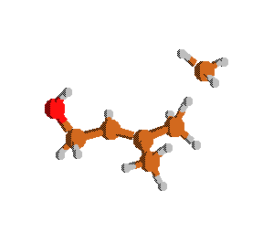**Rxn17 (trans)**

**TS CH3+CC(C)=CCOH => CH4+t-C=C(C)CJCOH**

Geometry [Angstroms]

6 -0.004475 -0.010259 0.026239

1 -0.113246 0.022202 1.106614

1 1.022350 -0.063792 -0.323876

1 -0.634344 0.688972 -0.516232

1 -0.568967 -1.310196 -0.353682

6 -1.003310 -2.445059 -0.728682

1 -0.449730 -3.125807 -0.078690

1 -0.665574 -2.521158 -1.762037

6 -2.469611 -2.487023 -0.555863

6 -2.939041 -2.672047 0.867879

1 -2.636474 -3.655514 1.244153

1 -4.019470 -2.592025 0.981395

1 -2.471050 -1.928553 1.522227

6 -3.288588 -2.332509 -1.615975

1 -2.834982 -2.207129 -2.597584

6 -4.786454 -2.292316 -1.642424

1 -5.217308 -2.355673 -0.636587

1 -5.178956 -3.137511 -2.216441

8 -5.271334 -1.131661 -2.329830

1 -4.870572 -0.366343 -1.904658

Rotational Constants [GHz] = 0.990 1.123 3.283

Frequencies [cm-1]

-1488.6895 23.7167 44.9724

72.1193 83.5369 131.8750

174.5983 266.9833 349.3227

368.3662 370.6437 435.1843

445.0168 494.3732 536.4490

599.7086 699.3083 802.1062

874.9753 957.8187 982.5848

1022.7860 1035.3337 1057.7474

1086.1691 1120.8802 1139.1029

1192.4774 1248.0637 1337.4811

1378.6589 1394.9694 1397.6125

1416.3207 1420.8801 1432.6194

1435.2114 1469.4392 1487.8995

1489.5479 1508.6150 1678.2538

3010.6975 3019.0874 3051.1501

3058.9536 3060.8496 3062.9392

3122.1511 3123.6421 3134.7512

3203.2144 3204.6860 3816.4861

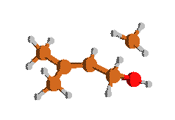

**Rxn18**

**TS CH3+CC(C)=CCOH_CH4+CC(C)=CCJOH**

Geometry [Angstroms]

6 -0.010855 -0.086706 0.031913

6 0.007130 0.020547 1.535147

6 1.123645 0.127568 2.273110

6 2.522149 0.116064 1.805694

8 3.334596 0.846397 2.701530

6 -1.350540 -0.009830 2.188702

1 1.030603 0.184947 3.355275

1 -0.699794 0.649449 -0.397814

1 0.969515 0.062592 -0.420940

1 -0.374587 -1.072866 -0.281065

1 -1.883915 -0.937340 1.946674

1 -1.279788 0.067573 3.275042

1 -1.978081 0.813240 1.826167

1 2.929381 -1.050492 1.802059

1 2.654020 0.438491 0.765736

1 4.251285 0.731631 2.433009

6 3.567884 -2.463110 1.850773

1 2.786350 -3.080111 1.418607

1 4.472807 -2.377805 1.256001

1 3.722896 -2.589721 2.917831

Rotational Constants [GHz] = 1.083 1.227 3.072

Frequencies [cm-1]

-1145.4313 38.1919 41.2162

63.7522 129.6104 140.6004

180.0505 207.2368 258.6426

308.7158 351.1411 418.3337

462.6835 484.6169 509.6861

530.3090 593.4530 821.5462

862.2053 962.2918 1006.7633

1012.1708 1060.9304 1073.9053

1098.5706 1111.3396 1131.0496

1208.3885 1274.8335 1314.0054

1360.9114 1410.3419 1418.8630

1420.4836 1423.9360 1454.7880

1463.7566 1473.2467 1486.6216

1491.8850 1497.9318 1710.9514

3001.6553 3006.2002 3011.1052

3041.3220 3048.1069 3064.3447

3102.0190 3113.2285 3135.6418

3206.2876 3212.6785 3829.7590

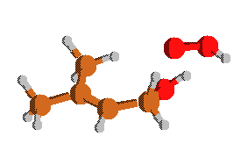

**Rxn22 (cis)**

**TS HO2+C2C=CCOH => H2O2+c-CC(C)=CCJOH**

Geometry [Angstroms]

6 -0.024153 0.065091 0.000023

1 -0.039766 0.024843 1.247722

1 1.056059 -0.033040 -0.189057

8 -0.508692 1.333246 -0.312834

1 -0.181943 1.936199 0.373872

8 -0.003614 0.485870 2.512246

8 0.326851 1.845502 2.345919

1 1.275404 1.865919 2.542161

6 -0.772825 -1.087237 -0.504873

1 -0.169934 -1.992425 -0.539285

6 -2.071427 -1.203572 -0.861293

6 -2.600168 -2.531713 -1.337190

1 -1.830745 -3.305650 -1.345789

1 -3.011278 -2.444574 -2.349915

1 -3.423571 -2.870881 -0.697384

6 -3.086269 -0.093978 -0.831028

1 -3.450703 0.110959 -1.845366

1 -3.959528 -0.407612 -0.247009

1 -2.685648 0.825287 -0.416736

Rotational Constants [GHz] = 0.815 0.851 3.676

Frequencies [cm-1]

-1234.7256 33.4602 62.6797

92.9078 110.3208 172.3608

190.6429 245.5167 271.4249

305.5137 356.0374 393.7926

436.0243 477.4000 581.0376

600.2036 702.5616 798.7990

843.1559 959.4883 976.3205

999.2780 1005.1023 1012.9154

1088.0970 1098.2722 1187.9225

1226.3903 1300.8931 1340.0690

1358.7679 1378.5599 1409.2889

1418.1233 1429.6617 1472.3361

1477.3136 1493.2821 1498.7887

1572.1884 1665.4935 2966.8191

3004.1455 3010.4160 3043.8535

3048.8245 3102.5276 3127.3403

3174.7878 3686.9937 3721.4375

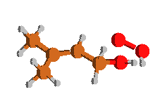

**Rxn22 (trans)**

**TS HO2+C2C=CCOH => H2O2+t-CC(C)=CCJOH**

Geometry [Angstroms]

6 -0.134778 0.097122 -0.025471

6 -0.019453 0.050868 1.474703

6 1.147747 -0.060096 2.141187

6 2.488289 -0.183545 1.569791

8 3.486541 0.181228 2.471757

6 -1.325446 0.122196 2.218887

8 3.420116 -2.511534 1.136988

8 4.752951 -2.078374 1.286989

1 1.129864 -0.115246 3.226502

1 0.829134 0.141493 -0.531783

1 -0.663437 -0.789946 -0.393924

1 -0.726372 0.964713 -0.338676

1 -1.987289 -0.701758 1.925813

1 -1.181442 0.076538 3.299368

1 -1.859858 1.049579 1.980831

1 2.719177 -1.388896 1.327531

1 2.622476 0.259692 0.573116

1 4.294113 -0.287043 2.209813

1 5.060392 -1.999763 0.371644

Rotational Constants [GHz] = 0.746 0.814 3.467

Frequencies [cm-1]

-1262.9999 43.3089 66.2281

86.8729 116.1027 170.7544

195.3581 200.4452 271.6172

295.7166 355.5277 419.5837

458.5129 468.9524 518.4820

572.4368 609.1164 824.3916

859.5575 961.4686 984.2647

1002.3051 1007.9543 1056.8921

1095.2601 1109.9731 1144.1136

1216.5005 1290.6855 1327.6182

1356.1130 1360.2328 1410.1736

1419.0295 1424.2773 1470.9980

1483.1971 1490.0292 1492.8735

1560.2354 1681.2645 2986.0044

3004.9731 3014.2256 3045.5945

3053.3386 3107.5388 3119.2578

3147.3611 3704.1230 3721.9021

**C=C(C)C=C**

Geometry [Angstroms]

6 -0.000028 0.000084 0.000040

1 -0.002707 0.000342 1.094796

1 1.047434 0.002647 -0.318265

1 -0.457899 -0.929122 -0.341765

6 -0.735498 1.198756 -0.544613

6 -1.805780 1.062633 -1.340946

6 -0.259797 2.540325 -0.188221

1 -2.332435 1.927005 -1.731022

1 -2.185484 0.087906 -1.625255

6 0.788149 2.824115 0.591616

1 -0.832283 3.362291 -0.612348

1 1.067793 3.849652 0.801584

1 1.400297 2.053036 1.045314

Rotational Constants [GHz] = 2.850 4.168 8.537

Frequencies [cm-1]

159.8516 200.3661 280.2193

409.0172 427.9214 537.0587

643.8355 786.1387 791.0768

922.0821 933.4094 959.7651

1010.8891 1028.3893 1070.3127

1088.4780 1325.5746 1328.3258

1411.0972 1429.7859 1458.8708

1482.9919 1503.0266 1659.3724

1698.7388 3022.3003 3069.6616

3109.9868 3128.9170 3134.0471

3143.9062 3215.2292 3222.3938

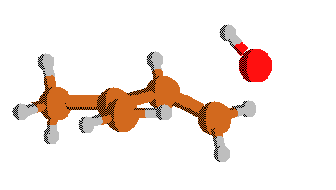**Rxn31 (cis)**

**TS c-C=C(C)CJCOH => C=C(C)C=C+OH**

Geometry [Angstroms] @ UQCISD-FC\6-31G(d)

6 0.029378 0.036668 0.009547

6 0.037283 0.010137 1.351354

6 1.300883 0.128667 2.113788

6 2.339147 0.928075 1.755583

8 3.357851 -0.354701 0.295226

6 -1.218331 -0.159329 2.174309

1 1.391123 -0.484527 3.014284

1 0.954299 0.106634 -0.557619

1 -0.899891 -0.032240 -0.553463

1 -2.100943 -0.262688 1.533423

1 -1.149568 -1.052923 2.810774

1 -1.370695 0.700981 2.839876

1 2.236964 1.654830 0.955493

1 2.929212 -1.190865 0.580998

1 3.226048 1.007237 2.377322

Rotational Constants [GHz] = 1.673 1.998 6.152

Frequencies [cm-1] @ UQCISD-FC\6-31G(d)

-323.0577 73.5137 124.7225

177.9684 192.1577 204.9022

282.3913 395.0139 436.7675

555.6780 696.8066 700.6796

798.5319 821.0638 937.1937

956.0150 989.1354 1002.2410

1043.6943 1090.5936 1125.2086

1303.2581 1330.0590 1457.0175

1482.5591 1493.3809 1530.0306

1545.9164 1641.1469 1739.1357

3056.3911 3117.8601 3151.7400

3161.0869 3180.9905 3204.7549

3271.2244 3293.6365 3664.4814

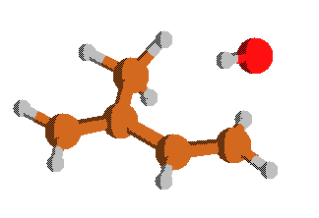**Rxn31 (trans)**

**TS t-C=C(C)CJCOH => C=C(C)C=C+OH**

Geometry [Angstroms] @ UQCISD-FC\6-31G(d)

6 0.022072 0.135337 0.092898

6 -0.028746 0.034969 1.432476

6 1.216553 -0.010442 2.284058

6 -1.334237 -0.011330 2.109581

6 -1.510584 -0.132854 3.449069

8 -1.129927 1.986094 4.056404

1 -2.212821 0.100066 1.470343

1 -0.882352 0.175226 -0.512494

1 0.967480 0.176527 -0.444145

1 2.114470 0.103826 1.667334

1 1.190920 0.792276 3.031308

1 1.291012 -0.963835 2.824200

1 -2.508133 -0.189270 3.875375

1 -1.393169 2.374735 3.193807

1 -0.688252 -0.341473 4.125238

Rotational Constants [GHz] = 1.877 2.076 5.100

Frequencies [cm-1] @ UQCISD-FC\6-31G(d)

-274.1259 76.0016 95.5481

184.5604 232.6282 239.5029

292.4149 427.2358 444.0406

538.5678 663.9436 667.6134

786.8163 809.7228 923.7290

931.5377 985.1123 1002.4285

1036.1259 1101.3770 1114.4768

1334.0709 1364.3702 1452.5186

1470.0251 1499.8521 1530.5630

1558.4108 1640.6559 1714.8140

3065.4114 3133.9507 3158.9751

3168.7593 3176.0601 3210.0288

3257.0847 3295.6533 3665.1511

**c-CC(C)=CC=O**

Geometry [Angstroms]

6 0.002914 -0.002165 0.003644

6 -0.001770 -0.008115 1.508183

6 1.171665 0.003181 -0.671340

6 -1.353259 -0.002734 -0.642417

6 1.375477 0.009437 -2.129611

1 2.095812 0.003026 -0.098343

1 -0.535284 -0.888252 1.884693

1 1.005648 -0.007586 1.926355

1 -0.539069 0.866718 1.891610

1 -1.922879 0.871590 -0.305905

1 -1.291653 0.001943 -1.726107

1 -1.918601 -0.882627 -0.313281

1 2.449976 0.013079 -2.416873

8 0.527333 0.010910 -2.999293

Rotational Constants [GHz] = 1.817 2.351 7.281

Frequencies [cm-1]

83.2772 113.3168 168.0311

242.1650 242.1786 375.2135

395.8217 486.5647 731.4472

833.9577 849.4372 955.0478

993.6698 1003.0093 1037.5189

1107.0259 1116.7750 1228.4399

1377.2880 1408.8529 1413.2703

1442.7145 1468.4056 1474.5212

1486.7332 1506.8606 1663.9999

1771.2211 2867.7417 3010.4285

3017.1609 3051.4685 3059.9746

3111.3999 3136.8274 3169.9500

**t-CC(C)=CC=O**

Geometry [Angstroms]

6 0.016661 -0.002129 -0.000090

6 -0.002063 -0.008224 1.504627

6 1.187160 0.003007 -0.666997

6 -1.346180 -0.002412 -0.641320

6 1.367580 0.009269 -2.121612

1 2.120894 0.002708 -0.111218

1 -0.536288 -0.888870 1.879272

1 1.003545 -0.007901 1.926282

1 -0.539807 0.867235 1.886330

1 -1.915285 0.872533 -0.308325

1 -1.322962 0.002136 -1.728912

1 -1.911490 -0.882538 -0.315590

1 0.448240 0.009888 -2.741570

8 2.457672 0.013680 -2.655402

Rotational Constants [GHz] = 1.592 1.944 7.941

Frequencies [cm-1]

117.2768 130.3355 185.8472

222.9414 232.6464 367.2280

470.5475 477.4172 535.9862

847.5639 866.2675 956.3340

1006.1034 1021.9833 1062.2509

1102.6460 1141.9362 1215.1062

1341.2762 1409.5958 1415.0789

1433.0081 1470.7183 1482.7563

1489.5219 1492.4940 1692.8730

1758.5513 2898.4189 3012.5752

3022.2473 3056.0779 3062.7104

3115.2695 3139.9353 3150.7830

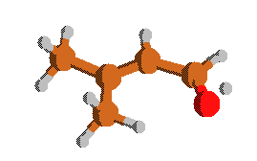

**Rxn33 (cis)**

**TS CC(C)=CCJOH => c-CC(C)=CC=O+H**

Geometry [Angstroms]

6 0.036584 -0.007135 -0.019053

6 -0.012085 0.006822 1.483962

6 1.231160 0.008763 -0.658473

6 -1.299784 -0.039646 -0.703201

6 1.494946 -0.001417 -2.088718

1 2.130807 0.037902 -0.048342

1 -0.550382 -0.871639 1.858192

1 0.982344 0.020492 1.932031

1 -0.566668 0.882831 1.839968

1 -1.919817 0.790080 -0.343852

1 -1.211520 0.014027 -1.783619

1 -1.832105 -0.959498 -0.432539

1 2.568505 -0.016982 -2.350971

8 0.658373 -0.015232 -3.003921

1 0.313427 -1.405140 -3.772853

Rotational Constants [GHz] = 1.761 2.257 6.937

Frequencies [cm-1]

-1055.6949 74.5718 106.3125

113.5507 167.8923 241.9655

258.8773 372.2068 395.4566

485.8950 496.7398 729.2581

839.6325 846.0785 957.2410

997.0938 1003.3203 1011.8020

1102.6395 1120.7715 1230.2917

1378.7035 1406.6552 1413.6199

1426.8636 1467.3044 1473.4956

1485.9210 1504.1072 1590.1923

1675.7863 2940.3872 3008.5647

3015.0342 3048.9204 3055.9609

3110.4988 3136.3040 3171.4612

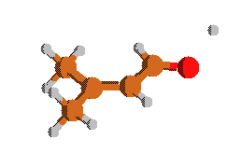**Rxn33 (trans)**

**TS CC(C)=CCJOH => t-CC(C)=CC=O+H**

Geometry [Angstroms]

6 0.011911 0.008053 0.006127

6 -0.008236 -0.016216 1.509531

6 1.187875 0.030665 -0.661423

6 -1.346485 -0.001757 -0.641553

6 1.369247 0.030777 -2.098506

1 2.117928 0.027485 -0.099533

1 -0.528847 -0.909392 1.874530

1 0.996726 -0.005493 1.932765

1 -0.560039 0.845927 1.901932

1 -1.934792 0.853584 -0.291054

1 -1.317166 0.029617 -1.728794

1 -1.897871 -0.900344 -0.342432

1 0.472766 0.078429 -2.737871

8 2.489564 -0.002417 -2.625804

1 3.045100 1.299150 -3.423377

Rotational Constants [GHz] = 1.529 1.841 7.730

Frequencies [cm-1]

-1061.4971 104.9615 116.6559

133.0586 177.7832 219.1968

243.6553 364.0088 453.4223

475.5626 512.5404 536.0450

846.7097 874.4831 957.6596

982.9819 1008.7309 1066.1711

1098.1840 1157.0479 1217.4359

1342.8398 1406.2208 1410.2616

1423.3777 1469.7069 1481.6998

1487.9645 1491.1118 1611.2811

1667.4026 2969.4480 3009.6953

3019.7942 3051.8721 3059.2107

3114.1267 3137.6921 3151.1665

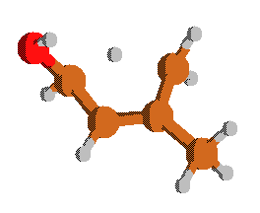

**Rxn34**

**TS CC(C)=CCJOH => C=C(C)CJCOH**

Geometry [Angstroms]

-1783.2719 127.2646 156.4852

193.8014 305.2725 394.1734

408.4386 438.3267 522.1052

560.0742 633.1541 827.2442

876.7899 928.1936 964.8164

986.6165 1032.2192 1049.9836

1101.7760 1132.3596 1206.2129

1241.2953 1315.5890 1392.0754

1409.7472 1426.8165 1441.0721

1477.5972 1485.5046 1639.2054

1703.4283 3011.7617 3058.2595

3059.6448 3081.4395 3091.7405

3128.3064 3142.6667 3804.5623

Rotational Constants [GHz] = 1.762 2.041 7.657

Frequencies [cm-1]

6 0.002407 -0.000101 0.000664

6 -0.000470 -0.004295 1.499329

6 1.235678 0.000629 -0.529256

6 -1.281755 -0.012465 -0.775464

6 2.327715 -0.016332 0.489182

1 1.442675 0.009299 -1.596499

1 -0.344150 -0.917616 1.986375

1 1.447011 0.028789 1.497636

1 -0.381285 0.892861 1.990481

1 -1.909293 0.842306 -0.499939

1 -1.104644 0.018994 -1.853322

1 -1.864272 -0.912324 -0.548753

1 2.877590 -0.951693 0.609376

8 3.259565 1.020768 0.445913

1 2.788373 1.828410 0.211493

**C2CJC(OH)COH**



Geometry [Angstroms]

6 0.258031 -0.249291 0.223321

6 -0.099112 0.446002 1.496540

6 1.630075 -0.082688 -0.341920

6 -0.659827 -1.305772 -0.313384

1 -1.171257 0.392189 1.707213

1 0.424599 0.020616 2.369151

1 0.185186 1.505124 1.463840

1 1.697631 -0.520108 -1.337856

1 1.903538 0.977630 -0.407218

1 2.399669 -0.555440 0.291935

1 -1.702716 -1.006822 -0.115005

8 -0.463583 -1.465000 -1.714942

6 -0.451417 -2.666332 0.370929

8 -1.345424 -3.584769 -0.270933

1 0.591545 -2.977695 0.234471

1 -0.669045 -2.590220 1.443583

1 -0.899245 -2.297082 -1.939947

1 -1.072622 -4.481411 -0.058595

Rotational Constants [GHz] = 1.402 1.661 4.030

Frequencies [cm-1]

49.3953 84.9284 114.7962

134.4374 162.8078 255.5216

284.5584 297.5390 328.2179

421.9480 493.3085 508.4544

551.3571 795.6683 887.5086

949.6274 975.3082 986.4591

1008.8839 1043.0105 1048.6864

1102.1254 1197.6046 1234.1674

1265.0769 1284.5778 1325.5450

1360.4406 1396.4033 1410.9117

1425.6385 1439.2953 1470.4689

1473.9312 1487.0171 1499.0596

1505.2936 2933.6519 2936.6978

2941.6189 2993.5312 3011.8997

3017.1716 3040.3679 3072.6799

3119.8811 3777.5095 3848.4194

**C2C=COH**

Geometry [Angstroms]

6 0.011077 -0.018435 -0.042501

6 -0.007181 -0.158173 1.457443

6 1.170939 -0.055190 -0.706225

6 -1.329531 0.158873 -0.707055

8 1.377687 0.053967 -2.053260

1 2.116327 -0.184510 -0.191657

1 -0.604065 -1.023844 1.770180

1 0.999068 -0.282543 1.863996

1 -0.454688 0.722425 1.934676

1 -1.839000 1.054013 -0.331545

1 -1.274741 0.257778 -1.795720

1 -1.987768 -0.692439 -0.497639

1 0.530664 0.168078 -2.497360

Rotational Constants [GHz] = 2.651 3.729 8.236

Frequencies [cm-1]

77.3932 194.3130 279.4630

286.7536 338.2336 365.7105

488.7004 575.7484 803.5699

885.7677 974.2265 1014.8379

1041.0736 1096.8408 1173.5275

1201.8408 1313.1622 1405.2354

1416.7430 1428.8317 1468.6907

1485.4146 1496.3425 1504.0724

1743.7111 2996.9009 3003.6177

3034.1382 3046.2441 3064.6128

3091.1633 3182.3616 3818.3799

**CH2OH**

Geometry [Angstroms]

6 0.071889 0.120362 0.048723

1 -0.030680 -0.005885 1.116927

1 1.019016 -0.067945 -0.445944

8 -0.770960 1.064386 -0.468638

1 -0.582479 1.175272 -1.405401

Rotational Constants [GHz] = 26.113 29.864 192.561

Frequencies [cm-1]

441.1690 587.2377 1061.8090

1207.2646 1367.2296 1487.7806

3111.3669 3255.5083 3840.8074

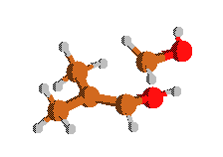

**Rxn43**

**TS C2CJC(OH)COH => C2C=COH+CH2OH**

Geometry [Angstroms]

6 -0.121940 -0.077167 0.034485

6 0.046310 -0.023678 1.524062

6 1.295088 0.159937 2.070347

6 2.347913 -1.821193 2.159023

8 2.881907 -1.832837 3.444267

6 -1.157557 -0.295274 2.374973

8 1.415869 0.456656 3.413968

1 0.812770 0.132883 -0.491776

1 -0.480220 -1.061968 -0.296792

1 -0.867847 0.651583 -0.308317

1 -0.918588 -0.214060 3.434918

1 -1.965285 0.413345 2.152435

1 -1.567252 -1.297500 2.181889

1 2.089385 0.547900 1.434191

1 1.587122 -2.571080 1.956303

1 3.133698 -1.722542 1.417656

1 2.249539 0.069991 3.719310

1 2.212588 -2.170642 4.048412

Rotational Constants [GHz] = 1.330 1.510 3.699

Frequencies [cm-1]

-491.9630 62.5040 106.7106

115.6556 143.5377 182.6487

233.5205 278.9000 283.5547

338.8100 388.1857 436.1457

537.7986 580.8569 616.8349

799.5107 873.9691 953.2153

969.5306 995.9578 1038.5934

1077.6941 1079.9216 1112.7668

1158.0525 1229.9700 1341.9293

1361.9945 1378.8031 1404.5415

1416.4983 1471.7097 1479.2889

1483.3486 1489.0077 1493.2351

1572.4746 2976.2786 2982.6636

3015.9009 3019.6340 3080.7153

3081.6743 3095.4580 3122.2024

3201.6973 3714.6670 3829.2920

**CC(C)=CC(OOJ)OH**

Geometry [Angstroms]

6 -0.064156 -0.030786 -0.028438

6 0.017532 0.049471 1.473546

6 0.993567 -0.429235 -0.744884

6 -1.391399 0.378438 -0.611688

6 1.066688 -0.535888 -2.222029

1 1.923642 -0.684892 -0.247260

1 -0.184233 1.069979 1.817770

1 -0.739820 -0.593288 1.936314

1 0.998166 -0.250890 1.844879

1 -2.202906 -0.197446 -0.153975

1 -1.588561 1.432425 -0.387280

1 -1.450289 0.256719 -1.692498

8 1.467870 0.850106 -2.754263

8 2.023101 -1.444641 -2.599681

1 0.105012 -0.697081 -2.719371

1 2.161583 -1.315490 -3.550298

8 1.896978 0.745474 -3.988512

Rotational Constants [GHz] = 0.962 1.072 3.933

Frequencies [cm-1]

32.1010 79.0981 109.6265

128.5335 186.3923 215.7218

307.5567 357.3730 386.0785

458.9609 476.8784 508.0403

509.0415 659.6394 702.3635

841.3404 871.5357 961.5666

1007.4074 1045.3696 1104.3628

1115.2285 1159.5734 1189.8005

1214.7469 1283.6250 1328.7605

1357.2858 1412.4062 1422.0560

1471.8196 1473.3661 1487.0594

1492.4800 1498.4061 1733.2793

3013.6880 3022.0137 3037.9353

3058.1250 3064.2693 3111.6526

3125.8113 3162.1089 3729.8401

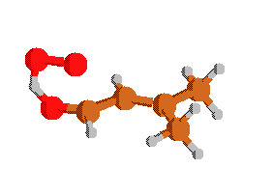

**Rxn48**

**TS CC(C)=CC(OH)OOJ => CC(C)=CCHO+HO2**

Geometry [Angstroms]

6 0.012772 0.000806 -0.014425

6 -0.004844 -0.039507 1.488366

6 1.350835 -0.002411 2.138592

6 -1.176638 -0.091175 2.154431

6 -1.347408 -0.148025 3.590254

8 -2.504368 -0.419197 4.088263

8 -1.448694 1.846814 4.229108

8 -2.527308 1.758075 4.919240

1 -2.109471 -0.098394 1.598600

1 0.520780 0.905111 -0.368710

1 0.575458 -0.849594 -0.416413

1 -0.992469 -0.018427 -0.436625

1 1.978993 -0.811420 1.750172

1 1.857459 0.935377 1.884725

1 1.321662 -0.081522 3.223567

1 -0.467560 -0.270455 4.225683

1 -2.769501 0.505230 4.680159

Rotational Constants [GHz] = 0.925 0.982 3.864

Frequencies [cm-1]

-633.8458 56.2452 72.8101

111.0562 136.7485 169.6417

222.9082 276.5411 355.4767

450.4925 481.4202 497.0307

499.6849 611.0162 798.4984

849.8149 879.4098 958.8356

979.9663 1004.7710 1068.1799

1099.4039 1101.2852 1164.1870

1223.3960 1309.6941 1342.0300

1382.2034 1411.0496 1420.3528

1469.0549 1480.6738 1487.0044

1490.5291 1555.2930 1689.2025

1886.9437 3012.2512 3022.1260

3055.4712 3063.1575 3074.1658

3114.9185 3137.2900 3158.3381

**References**

[1] M. K. Sabbe, A. Vandeputte, M.-F. Reyniers, M. Waroquier, G. B. Marin, Modeling the influence of resonance stabilization on the kinetics of hydrogen abstractions, PCCP 12 (2010) 1278-1298

[2] P. D. Paraskevas, M. K. Sabbe, M.-F. Reyniers, N. G. Papayannakos, G. B. Marin, Kinetic Modeling of α-Hydrogen Abstractions from Unsaturated and Saturated Oxygenate Compounds by Carbon-Centered Radicals, ChemPhysChem 15 (2014) 1849-1866

[3] J. Mendes, C.-W. Zhou, H. J. Curran, Theoretical Chemical Kinetic Study of the H-Atom Abstraction Reactions from Aldehydes and Acids by Ḣ Atoms and ȮH, HȮ2, and ĊH3 Radicals, J. Phys. Chem. A 118 (2014) 12089-12104

[4] P. D. Paraskevas, M. K. Sabbe, M.-F. Reyniers, N. G. Papayannakos, G. B. Marin, Kinetic Modeling of α-Hydrogen Abstractions from Unsaturated and Saturated Oxygenate Compounds by Hydrogen Atoms, J. Phys. Chem. A 118 (2014) 9296-9309

[5] R. Sivaramakrishnan, J. V. Michael, Rate Constants for OH with Selected Large Alkanes: Shock-Tube Measurements and an Improved Group Scheme, J. Phys. Chem. A 113 (2009) 5047-5060

[6] J. Badra, A. Elwardany, A. Farooq, Shock tube measurements of the rate constants for seven large alkanes + OH, P. Combust. Inst. 35 (2015) 189-196

[7] P. D. Paraskevas, M. K. Sabbe, M.-F. Reyniers, N. G. Papayannakos, G. B. Marin, Group Additive Kinetics for Hydrogen Transfer Between Oxygenates, J. Phys. Chem. A (2015)

[8] J. Aguilera-Iparraguirre, H. J. Curran, W. Klopper, J. M. Simmie, Accurate Benchmark Calculation of the Reaction Barrier Height for Hydrogen Abstraction by the Hydroperoxyl Radical from Methane. Implications for CnH2n+2 where n = 2 → 4, J. Phys. Chem. A 112 (2008) 7047-7054

[9] G. Mittal, S. M. Burke, V. A. Davies, B. Parajuli, W. K. Metcalfe, H. J. Curran, Autoignition of ethanol in a rapid compression machine, Combust. Flame 161 (2014) 1164-1171

[10] J. Zádor, S. J. Klippenstein, J. A. Miller, Pressure-Dependent OH Yields in Alkene + HO2 Reactions: A Theoretical Study, J. Phys. Chem. A 115 (2011) 10218-10225

[11] H. J. Curran, P. Gaffuri, W. J. Pitz, C. K. Westbrook, A comprehensive modeling study of n-heptane oxidation, Combust. Flame 114 (1998) 149-177

[12] H. J. Curran, P. Gaffuri, W. J. Pitz, C. K. Westbrook, A comprehensive modeling study of iso-octane oxidation, Combust. Flame 129 (2002) 253-280

[13] K. Wang, S. M. Villano, A. M. Dean, Reactivity–Structure-Based Rate Estimation Rules for Alkyl Radical H Atom Shift and Alkenyl Radical Cycloaddition Reactions, J. Phys. Chem. A 119 (2015) 7205-7221

[14] J. Bugler, K. P. Somers, E. J. Silke, H. J. Curran, Revisiting the Kinetics and Thermodynamics of the Low-Temperature Oxidation Pathways of Alkanes: A Case Study of the Three Pentane Isomers, J. Phys. Chem. A 119 (2015) 7510-7527

[15] F. Zhang, T. S. Dibble, Effects of Olefin Group and Its Position on the Kinetics for Intramolecular H-Shift and HO2 Elimination of Alkenyl Peroxy Radicals, J. Phys. Chem. A 115 (2011) 655-663

[16] H. Sun, J. W. Bozzelli, C. K. Law, Thermochemical and Kinetic Analysis on the Reactions of O2 with Products from OH Addition to Isobutene, 2-Hydroxy-1,1-dimethylethyl, and 2-Hydroxy-2-methylpropyl Radicals:  HO2 Formation from Oxidation of Neopentane, Part II, J. Phys. Chem. A 111 (2007) 4974-4986

[17] M. K. Sabbe, M.-F. Reyniers, V. Van Speybroeck, M. Waroquier, G. B. Marin, Carbon-centered radical addition and beta-scission reactions: Modeling of activation energies and pre-exponential factors, ChemPhysChem 9 (2008) 124-140

[18] M. K. Sabbe, M.-F. Reyniers, M. Waroquier, G. B. Marin, Hydrogen Radical Additions to Unsaturated Hydrocarbons and the Reverse beta-Scission Reactions: Modeling of Activation Energies and Pre-Exponential Factors, ChemPhysChem 11 (2010) 195-210

[19] C. F. Goldsmith, S. J. Klippenstein, W. H. Green, Theoretical rate coefficients for allyl + HO2 and allyloxy decomposition, P. Combust. Inst. 33 (2011) 273-282

[20] G. da Silva, J. W. Bozzelli, L. Liang, J. T. Farrell, Ethanol Oxidation: Kinetics of the α-Hydroxyethyl Radical + O2 Reaction, J. Phys. Chem. A 113 (2009) 8923-8933

[21] J. Lee, J. W. Bozzelli, Thermochemical and kinetic analysis of the allyl radical with O2 reaction system, P. Combust. Inst. 30 (2005) 1015-1022