**Additional file 2 Figure S1**

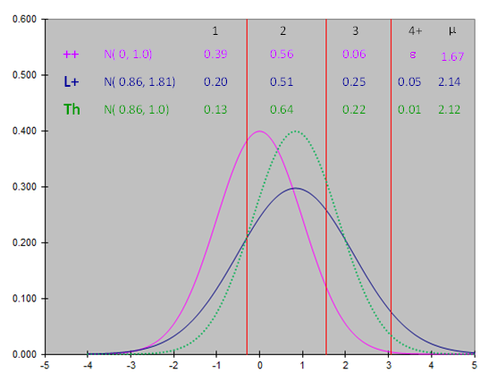**Figure S1: Distribution of underlying normal variables and the transformed common set {c} of thresholds**

The purple line represents the underlying variable y++ ~ N(0,1) providing the estimated proportions of LS in ++ ewes; the blue line represents the transformed underlying variable yL+ ~ N for L+ ewes providing the estimated proportions of LS in L+ ewes; the green-dotted line represents a theoretical underlying variable yL+* ~ N, with the same mean as for L+ ewes and a standardized residual variance as for ++ ewes.