Supporting Online Material for

Time-Resolved Holography with Photoelectrons

Y. Huismans, A. Rouzée, A. Gijsbertsen, J.H. Jungmann, A.S. Smolkowska, P.S.W.M. Logman, F. Lépine, C. Cauchy, S. Zamith, T. Marchenko, J.M. Bakker, G. Berden, B. Redlich, A.F.G. van der Meer, H.G. Muller, W. Vermin, K.J. Schafer, M. Spanner, M.Yu. Ivanov, O. Smirnova, D. Bauer, S.V. Popruzhenko and M.J.J. Vrakking*

* To whom correspondence should be addressed. E-mail: huismans@amolf.nl (Y.H.), marc.vrakking@mbi-berlin.de (M.V.)

This Word file includes:

Materials and Methods
SOM Text
Figs. S1 to S5
References
Methods

The configuration of the FELICE resonator for intra-cavity experiments and the integrated experimental setup are shown in Fig. S1. In the experiment, Xenon atoms that were injected into the vacuum using a pulsed gas nozzle were excited to the 6s[²P_{3/2}]_{J=2} metastable state by means of electron impact. After transport to the center of the velocity map imaging spectrometer, they were exposed to the FELICE laser. The FELICE radiation consists of an approximately 5 μs long macro-pulse that contains micro-pulses with a repetition rate of 16 MHz or a 1 GHz; the latter has been used here. The wavelength of the radiation is tunable between 4 and 100 μm. The pulse duration of the FELICE laser is variable and has for these experiments been estimated to be about 15 optical cycles long. The Rayleigh range of the intra-cavity focus is 55 mm, resulting in a maximal power density of 3x10²³/λ² W/cm² with the wavelength λ given in μm (17). For the wavelength used in these experiments, 7 μm, this gives an approximate focused intensity of 6x10¹¹ W/cm².
Electrons that were formed by strong-field ionization were accelerated perpendicularly to the FELICE laser polarization towards a two-dimensional position-sensitive detector, consisting of a dual microchannel plate (MCP) detector, followed by a phosphor screen and a CCD camera system. 3D velocity and angular distributions were extracted from the measured data using an iterative procedure.

Strong Field Electron Holography: SFA approximation.

General idea
A hologram is an interference pattern between two coherent beams of light or electrons that follow a different path; a direct beam that goes straight to a detector and an indirect beam that scatters off an object before going to the detector. In the hologram the shape of the object is encoded. In our article we describe ‘Strong Field Electron Holography’. In this case a coherent electron source is created at some distance away from the ion by tunnel-ionization in the oscillating electric field of a laser pulse. After ionization the electron wave packet oscillates in the laser field and can be driven back to the ion and scatter off before it goes to the detector. It can also go to the detector directly. The interference of these two electron wave packets forms a hologram that stores both the spatial information about the core and time information on the dynamics of both the electron source and the core.

The ability to split the electron wave-function into reference and signal waves is at the heart of strong field electron holography (see also Eq. (1) in the article):
$ψ=ψ_{\text{signal}}+ψ_{\text{ref}}$ (S1)

The signal wave packet represents the part that scatters off the ion. The reference wave packet represents the part that goes directly to the detector. Let us identify these terms in the exact solution of the time-dependent Schrödinger equation (TDSE).
The full equation for the exact wave-function that satisfies the TDSE reads (S2):

$ψ=−\int_{t_{0}}^{t}{\int_{0}^{t}{{\text{dt}}_{c}{\text{dt}}_{0}U_{V}\left(t,t_{C}\right)V_{C}\left(t_{C}\right)}U\left(t_{C},t_{0}\right)V_{L}\left(t_{0}\right)U_{0}\left(t_{0},0\right)ψ\left(0\right)}$ (S2) $−i\int_{0}^{t}{{\text{dt}}_{0}U_{V}\left(t,t_{0}\right)}V_{L}\left(t_{0}\right)U_{0}\left(t_{0},0\right)ψ\left(0\right)+U_{0}\left(t,0\right)ψ\left(0\right)$

The first term represents the signal wave packet that stays in the bound state until t₀, evolving under the action of the field-free propagator U₀. At t₀, which can be called the ionization time, the initial state is ionized by the laser field $V_{L}\left(t_{0}\right)$ and starts to propagate in the combined fields of the ionic core and the laser by the full propagator$U\left(t_{C},t_{0}\right)$. The time t_{C} can be associated with the collision time, at which the returning electron scatters of the ion with the scattering potential$V_{C}\left(t_{C}\right)$. From there, it is propagated towards the detector by the propagator$U_{V}\left(t,t_{C}\right)$. Note that this latter propagator only includes the interaction with the laser field and not with the potential of the parent ion (the target).
The second term represents the reference wave packet. Just as the signal wave packet, it stays in the ground state until the time t₀, when it is ionized by the laser$V_{L}\left(t_{0}\right)$ and propagated towards the detector by $U_{V}\left(t,t_{0}\right)$. Note that, once again, the propagator $U_{V}\left(t,t_{0}\right)$ includes only the laser field. The last term describes the non-ionized system. We stress that the full expression in Eq. (S2) is the exact formal solution of the TDSE

In the following sections Eq. (S2) will be derived and the derivation of the phase-difference between the signal and reference waves will be given. We will also focus on different types of patterns in the photo-electron velocity map images that originate from different types of electron wave packet interferences.

Derivation of the Exact Expression and the Strong Field Approximation (SFA) to Holography
In this section we will derive Eq. (S2). We start with the TDSE in atomic units:

$i\frac{∂ψ}{∂t}=Hψ$ (S3)

Here H is the full Hamiltonian of the system. The time-evolution of the wave function can be obtained by using a time propagator$U\left(t,0\right)$, which propagates the wave packet in time from t=0 to t:

$ψ\left(t\right)=U\left(t,0\right)ψ\left(0\right)$ (S4)

$U\left(t,0\right)$ is formally expressed by the equation:

$U\left(t,0\right)=\text{exp}\left[−i\int_{0}^{t}{dτH\left(τ\right)}\right]$ (S5)

where the time-ordering operator is omitted for brevity.

Let us now split the Hamiltonian into two parts:$H=H_{0}+V_{L}$with the unperturbed Hamiltonian $H_{0}={p^{2}}/2+V_{C}$, the scattering potential $V_{C}$ and the laser field $V_{L}$.

By using a Dyson series we can write a different exact expression for the propagator$U\left(t,0\right)$:

$U\left(t,0\right)=U_{0}\left(t,0\right)−i\int_{0}^{t}{{\text{dt}}_{0}U\left(t,t_{0}\right)}V_{L}U_{0}\left(t_{0},0\right)$ (S6)

Here $U_{0}\left(t,0\right)=\text{exp}\left[−{\text{iH}}_{0}t\right]$ is the field-free propagator. The exact solution to the Schrödinger equation can now be written as:

$ψ\left(t\right)=U_{0}\left(t,0\right)ψ\left(0\right)−i\int_{0}^{t}{{\text{dt}}_{0}U\left(t,t_{0}\right)}V_{L}U_{0}\left(t_{0},0\right)ψ\left(0\right)$ (S7)

To describe the electron dynamics in the continuum at $t>t_{0}$, we apply a different partitioning to the Hamiltonian:$H=H_{V}+V_{C}$, with $H_{V}={p^{2}}/2+V_{L}$representing the interaction with the laser and $V_{C}$ representing the scattering potential. The exact expression for the full propagator reads:

$U\left(t,t_{0}\right)=U_{V}\left(t,t_{0}\right)−i\int_{t_{0}}^{t}{{\text{dt}}_{C}U_{V}\left(t,t_{C}\right)}V_{C}\left(t_{C}\right)U\left(t_{C},t_{0}\right)$ (S8)
where $U_{V}\left(t,t_{0}\right)=\text{exp}\left[−i\int_{t}^{t}{dτ}H_{V}\left(τ\right)\right]$ is the so-called Volkov propagator that neglects the interaction with the ion but includes the laser field fully.

If we substitute Eq. (S8) into Eq. (S7) we obtain the full solution including ionization and scattering.

$ψ=−\int_{t_{0}}^{t}{\int_{0}^{t}{{\text{dt}}_{c}{\text{dt}}_{0}U_{V}\left(t,t_{C}\right)V_{C}\left(t_{C}\right)}U\left(t_{C},t_{0}\right)V_{L}\left(t_{0}\right)U_{0}\left(t_{0},0\right)ψ\left(0\right)}$ (S9)
$$−i\int_{0}^{t}{{\text{dt}}_{0}U_{V}\left(t,t_{0}\right)}V_{L}\left(t_{0}\right)U_{0}\left(t_{0},0\right)ψ\left(0\right)+U_{0}\left(t,0\right)ψ\left(0\right)$$

The first term represents the part of the wave packet that scatters – the signal wave packet. The second term is the reference wave packet. The third term represents the part of the wave packet that remains in the bound state, which is irrelevant for the photo-electron spectra.

For the amplitude of detecting the electron with the final momentum p we have:

$a_{p}=−\int_{t_{0}}^{t}{\int_{0}^{t}{{\text{dt}}_{c}{\text{dt}}_{0}⟨p|U_{V}\left(t,t_{C}\right)V_{C}\left(t_{C}\right)}U\left(t_{C},t_{0}\right)V_{L}\left(t_{0}\right)U_{0}\left(t_{0},0\right)|ψ\left(0\right)⟩}$ (S10)
$$−i\int_{0}^{t}{{\text{dt}}_{0}⟨p|U_{V}\left(t,t_{0}\right)}V_{L}\left(t_{0}\right)U_{0}\left(t_{0},0\right)|ψ\left(0\right)⟩$$

Here $p=\left(p_{r},p_{z}\right)$ is the final momentum, z is the direction of the laser polarization and r the direction orthogonal to it. Eqs. (S9, S10) complete the derivation of the Eq. (S2). And the two terms in Eq. (S10) can be associated with the signal and the reference wave packets. Note that the second partitioning made ($H=H_{V}+V_{C}$), is only valid when$p_{r}\text{>>}p_{r}^{C}$, where$p_{r}^{C}$ is the perpendicular momentum acquired due to the interaction with the scattering potential. For$p_{r}\text{\sim }p_{r}^{C}$a different partitioning scheme should be used, which will be described elsewhere. This completes the discussion of the exact formal expressions for the holographic pattern.

The further analysis can be simplified by using the strong-field approximation for the evolution between $t_{0}$and $t_{C}$ in the first term in Eq. (S10).
Using the resolution of identity on momentum states represented by plane waves $\int{\text{dk}|k⟩⟨k|=1}$we obtain:

$$a_{p}=\left\langle p | ψ\right\rangle =−\int_{t_{0}}^{t}{{\text{dt}}_{C}}\int_{0}^{t}{{\text{dt}}_{0}}\int{\text{dk}⟨p|}U_{V}\left(t,t_{C}\right)V_{C}\left(t_{C}\right)|k⟩⟨k|U_{V}\left(t_{C},t_{0}\right)V_{L}\left(t_{0}\right)U_{0}\left(t_{0},0\right)|ψ\left(0\right)⟩$$
$$−i\int_{0}^{t}{{\text{dt}}_{0}}⟨p|U_{V}\left(t,t_{0}\right)V_{L}\left(t_{0}\right)U_{0}\left(t_{0},0\right)|ψ\left(0\right)⟩$$

$\begin{aligned}=−\int_{t_{0}}^{t}{{\text{dt}}_{C}}\int_{0}^{t}{{\text{dt}}_{0}}\int{dk}\text{exp}\left[−\frac{i}{2}\int{dτ}{\left(p+A(τ)\right)}^{2}\right]⟨p(t_{C})|V_{C}\left(t_{C}\right)|k⟩ \\ \text{exp}\left[−\frac{i}{2}\int_{t_{0}}^{t_{C}}{dτ}{\left(k+A(τ)\right)}^{2}\right]⟨k(t_{0})|V_{L}\left(t_{0}\right)|ψ(t_{0})⟩\text{exp}\left[{\text{iIPt}}_{0}\right]\end{aligned}$$−i\int_{0}^{t}{{\text{dt}}_{0}}\text{exp}\left[−\frac{i}{2}\int_{t_{0}}^{t}{dτ}{\left(p+A(τ)\right)}^{2}\right]⟨p(t_{0})|V_{L}\left(t_{0}\right)|ψ(t_{0})⟩\text{exp}\left[{\text{iIPt}}_{0}\right]$ (S11)

Here the application of SFA resulted in the substitution of the full propagator $U$by $U_{V}$.
In this equation $A\left(t\right)=−A_{0}\text{sin}ωt$ is related to the laser field strength E(t) as$E\left(t\right)=−∂A(t)/∂t$, $p=\left(p_{r},p_{z}\right)$is the final momentum, z is the direction of the laser polarization, $k=\left(k_{r},k_{z}\right)$ is the momentum before scattering, and IP is the ionization potential.

Rewriting Eq. (S11) in a simpler form and omitting the pre-exponential term one obtains:

$a=\left\langle p | ψ\right\rangle \text{\sim }−\int_{t_{0}}^{t}{{\text{dt}}_{C}}\int_{0}^{t}{{\text{dt}}_{0}}\int{dk\text{exp}\left[−{\text{iS}}_{\text{signal}}\left(t,t_{C}\right)\right]}−i\int_{0}^{t}{{\text{dt}}_{0}}\text{exp}\left[−{\text{iS}}_{\text{ref}}\left(t,t_{0}\right)\right]$, (S12)
where
$S_{\text{signal}}=\frac{1}{2}\int_{t_{C}}^{t}{dτ}{\left(p+A(τ)\right)}^{2}+\frac{1}{2}\int_{t_{0}}^{t_{C}}{dτ}{\left(k+A(τ)\right)}^{2}−{\text{IPt}}_{0}$,
and
$S_{\text{ref}}=\frac{1}{2}\int_{t_{0}}^{t}{dτ}{\left(p+A(τ)\right)}^{2}−{\text{IPt}}_{0}$.

There are four integrals to evaluate. Evaluation of the integrals is done by using the saddle point method, which requires one to find the point at which the derivative of S with respect to the integral variable is zero.

The first saddle point equation is derived by taking the derivative with respect to t₀:

${{\text{dS}}_{\text{ref}}}/{{\text{dt}}_{0}}=0⇒\frac{1}{2}(p_{z}−A_{0}\text{sin}({ωt}_{0}))^{2}=−\frac{1}{2}p_{r^{2}}−I_{P}$ (S13)
${{\text{dS}}_{\text{signal}}}/{{\text{dt}}_{0}}=0⇒\frac{1}{2}(k_{z}−A_{0}\text{sin}({ωt}_{0}))^{2}=−\frac{1}{2}k_{r^{2}}−I_{P}$

From these equations it follows that a non-zero initial orthogonal momentum corresponds to a higher effective ionization potential${\text{IP}}_{\text{eff}}=\text{IP}+\left(1/2\right)k_{r^{2}}$.
Note that $t_{0}$is complex: $t_{0}=t_{0}^{'}+it_{0}^{''}$.The phase terms above includes integration in real time from $t_{0}$to $t_{C}$. Integration in complex time from t₀ to the real axis yields the following additional phase:

$$S_{\text{ref}}^{\text{Im}}=\frac{1}{2}\int_{t_{0}^{''}}^{0}{dτ^{''}}{\left(p+A(τ^{''})\right)}^{2}$$
$=\frac{A_{0}^{2}}{ω}\left[\text{sin}\left({ωt}_{B}\right)\text{cos}\left(ωt_{0}^{'}\right)\left(1−\text{cosh}\left(ωt_{0}^{''}\right)\right)+\frac{1}{2}\text{sin}\left(ωt_{0}^{'}\right)\text{cos}\left(ωt_{0}^{'}\right)\left(1−\text{cosh}\left(2ωt_{0}^{''}\right)\right)\right]$ (S14)

The same can be done for the expression representing the signal wave$S_{\text{signal}}^{\text{Im}}$.
By making use of Eq. (S13) the following expression for $t_{0}$can be obtained (S5):

$$t_{0}=\frac{1}{ω}\left(\text{arcsin}\sqrt{P}+i\text{arccos}h\left(\frac{S}{\sqrt{P}}\right)\right)$$
$$S=\text{sin}\left({ωt}_{B}\right)$$
$P=\frac{1}{2}(1+γ^{2}+S^{2}−\sqrt{D})$ (S15)
$$D=(1−γ^{2})^{2}+S^{4}+2S^{2}(γ^{2}−1)$$

The time $t_{B}$is defined as the moment when the velocity on the electron trajectory is equal to zero, formally parameterizing$k_{z}$as$k_{z}=A_{0}\text{sin}({ωt}_{B})$and linking the quantum analysis, which yields complex ionization times associated with tunneling, to the classical three-step model (see below).

The second saddle-point equation tells us that the signal wave packet ionizes with zero orthogonal momentum:

${\text{dS}}/{{\text{dk}}_{r}}=0⇒k_{r}=0$ (S16)

It readily follows from Eqs. (S13, S16) that the time of ionization of the reference beam is not the same as the time of ionization of the signal beam, i.e. $t_{0}^{\text{ref}}≠t_{0}^{\text{signal}}$.

The third saddle-point equation leads to the following expression:

${\text{dS}}/{{\text{dk}}_{z}}=0⇒\int_{t_{0}}^{t_{C}}{\frac{∂}{∂k_{z}}}{\left[k_{z}−A_{0}\text{sin}(\text{ωτ})\right]}^{2}dτ=0$ (S17)

It is convenient to evaluate this integral via splitting it into three parts:

$\int_{t_{0}}^{t_{C}}{dτ}=\int_{t_{R}}^{t_{C}}{dτ}+\int_{t_{B}}^{t_{R}}{dτ}+\int_{t_{0}}^{t_{B}}{dτ}$

As introduced before, $t_{0}$ is the starting time for tunneling, $t_{B}$ is the moment when the electron velocity is equal to zero, which within the classical three-step model can be associated with the moment when the wave packet exits the barrier at a distance $z_{0}$from the origin, and $t_{C}$ is the moment of re-collision, see Fig. S2. The return time $t_{R}$ is the moment at which the electron returns to the position it had at t_{B}, associated with the tunnel exit point$z_{0}$. This analysis explicitly neglects the possible tunneling of the returning electron back into the classically forbidden region when returning to the origin.

It follows that

$\int_{t_{B}}^{t_{R}}{\frac{∂}{∂k_{z}}}{\left[k_{z}−A_{0}\text{sin}(\text{ωτ})\right]}^{2}{\text{dt}}_{C}=0⇒\text{sin}\left({ωt}_{B}\right)\left({ωt}_{R}−{ωt}_{B}\right)+\text{cos}\left({ωt}_{R}\right)−\text{cos}\left({ωt}_{B}\right)=0$ (S18)

where again we have used the parameterization, $k_{z}=A_{0}\text{sin}({ωt}_{B})$. From this equation we can obtain the relation between $t_{B}$ and $t_{R}$ numerically, e.g. by using Newton’s method.
From splitting the integrals it also follows that:

$\int_{t_{R}}^{t_{C}}{dτ}{\left[k_{z}−A_{0}\text{sin}(\text{ωτ})\right]}^{2}=−\int_{t_{0}}^{t_{B}}{dτ}{\left[k_{z}−A_{0}\text{sin}(\text{ωτ})\right]}^{2}=−z_{0}$ (S19)

Neglecting the small imaginary component of z₀, we obtain the relation between $t_{R}$ and $t_{C}$, while the relation between $t_{0}$ and $t_{B}$ is given by Eq. (S15).

The fourth and last saddle-point equation gives the relation between $p_{z}$ and $p_{r}$.

${\text{dS}}/{{\text{dt}}_{C}}=0⇒p_{z}=−A_{0}\text{sin}\left({ωt}_{c}\right)±\sqrt{{\left(−A_{0}\text{sin}\left({ωt}_{B}\right)+A_{0}\text{sin}\left({ωt}_{C}\right)\right)}^{2}−p_{r^{2}}}$ (S20)

By applying all the saddle-point equations and including the complex integration Eq. (S11) reduces to:

$$\left\langle p | ψ(t)\right\rangle \text{\sim }\text{exp}\left[−\frac{i}{2}\int_{t_{C}}^{t}{dτ}{\left(p_{z}+A(τ)\right)}^{2}−\frac{i}{2}p_{r^{2}}(t−t_{C})−\frac{i}{2}\int_{t_{0}^{\text{signal}}}^{t_{C}}{dτ}{\left(k_{z}+A(τ)\right)}^{2}+\text{iIP}t_{0}^{\text{signal}}+{\text{iS}}_{\text{signal}}^{\text{Im}}\right]$$
$+\text{exp}\left(−\frac{i}{2}\int_{t_{0}^{\text{ref}}}^{t}{dτ(p_{z}+A}(τ))^{2}−\frac{i}{2}p_{r^{2}}(t−t_{0}^{\text{ref}})+{\text{iIPt}}_{0}^{\text{ref}}+{\text{iS}}_{\text{reference}}^{\text{Im}}\right)$ (S21)

Since we are interested in the interference we need to calculate the acquired phase difference between the reference and signal wave packet.

$$Δφ=φ_{\text{signal}}−φ_{\text{ref}}=−\frac{1}{2}\int_{t_{0}^{\text{signal}}}^{t_{C}}{dτ}{\left(k_{z}+A(τ)\right)}^{2}−\frac{1}{2}p_{r^{2}}(t_{C}−t_{0}^{\text{ref}})+\frac{1}{2}\int_{t_{0}^{\text{ref}}}^{t_{C}}{dτ}{\left(p_{z}+A(τ)\right)}^{2}$$
$+\text{IP}\left(t_{0}^{\text{signal}}−t_{0}^{\text{ref}}\right)+S_{\text{signal}}^{\text{Im}}−S_{\text{reference}}^{\text{Im}}$ (S22)

Here the second term is identified as the dominant term accounting for the phase difference in holographic structures. The resulting holographic structures are shown in Fig. S3A. Here we also include the amplitude factor reflecting the shape of the electron wave packet in transversal direction (S6):

$ψ\left(p_{r}\right)=ψ\left(0\right)\text{exp}\left[−\frac{p_{r}^{2}}{2}τ\right]$ (S23)

Where τ is the imaginary part of t₀.

Time information in Hologram
Since the second term in Eq. (S22) is identified as the dominant term accounting for the phase difference in holographic structures, we can write:

$$Δφ≈p_{r}^{2}(t_{C}−t_{0}^{\text{ref}})/2$$

Thus, the hologram can be viewed as a pump-probe experiment, where the moment of birth of the reference wave packet t₀^{ref} starts an experiment, while at a later time t_{C} the scattering potential is probed. If the scattering potential changes between t₀^{ref} and t_{C}, this will be encoded in the hologram. In Fig. S3B the relation between (p_{z}, p_{r}) and the time differences t_{C} – t₀^{ref} is shown. In addition, t_{C}, is directly related to the time-of-birth of the signal wave packet t₀^{signal}. Therefore, changes in the ionization between t₀^{ref} and t₀^{signal} are recorded as well. In Fig. S3C the relation between (p_{z}, p_{r}) and the time differences t₀^{signal}- t₀^{ref} is shown. The interfering trajectories that produce the characteristic fringe pattern in Fig. S3A originate from the same quarter cycle. Thus, sub-cycle time resolution is obtained even when long pulses are used.

Different wave packet interferences
The saddle point method allows one to identify different types of trajectories leading to interference structures in the photoelectron spectrum. In Fig. S4 these different types of interferences and the corresponding ionization times are shown. Fig. S4A shows the well-known ATI structure. The ATI rings originate from the interference between electron wave packets that are ionized exactly one full cycle apart from each other. Fig. S4B shows another type of the interference pattern which arises from the interference of two wave packets ionized at instants t₁ and t₂ within the same laser cycle, for which A(t₁)=A(t₂) where the laser electric field has opposite values, E(t₁)=-E(t₂). That is, the two wave packets appear on the opposite sides of the ion but have the same drift momentum. Before reaching the detector, the first wave packet is turned around by the laser field while the second wave packet drifts directly to the detector without revisiting the parent ion. Both types of interference cause a pattern in the radial direction.
Completely different patterns are caused by the interference of electron wave packets originating from the same quarter of the laser cycle. This is the type of interference responsible for the hologram as shown in Fig. S4C.

CCSFA algorithm

To be able to include the Coulomb force properly, we turn to another method, the Coulomb Corrected Strong Field Approximation (CCSFA), which is the basis for the calculation of the momentum distribution displayed in fig. 4b in the article. For a full understanding of this method an introduction into the standard Strong Field Approximation (referred to as plain SFA below) is essential. Within the standard Strong Field Approximation the transition amplitude from an initial bound atomic state $|Ψ_{i}⟩$ into a state with asymptotic momentum $p$ is given by the matrix element:

$M_{\text{SFA}}\left(p\right)=−i\int_{−∞}^{+∞}{⟨Ψ_{p}^{V}|} V_{F}\left(t\right) |Ψ_{i}⟩ \text{dt}$, (S23)

where $|Ψ_{p}^{V}⟩$ is a Volkov state, i.e. the exact solution to the Schrödinger (Dirac) equation for an electron in the field of a plane electromagnetic wave. In the nonrelativistic dipole approximation sufficient for our purposes the respective wave function has the form (in the length gauge):

$Ψ_{p}^{V}\left(r,t\right)={\left(2π\right)}^{{−3}/2}\text{exp}\left\{{iv}_{p}⋅p−\frac{i}{2}\int_{−∞}^{t}{v_{p}^{2}\left(t^{'}\right)dt^{'}}\right\}\text{.}$ (S24)

Here $v_{p}\left(t\right)=p+A\left(t\right)$ is the time-dependent electron velocity in the field described by the vector potential $A\left(t\right)$ and $p$ is the asymptotic (drift) momentum. The electric field of the wave is $E\left(t\right)=−∂A/∂t$. In the same gauge the interaction operator is given by:

$V_{F}\left(t\right)=r⋅E\left(t\right)$ (S25)

When the photon energy is much less than the ionization potential of the bound state, $ℏω\text{<<}I_{p}$, so that ionization may only proceed via multi-photon absorption and, therefore, a highly nonlinear interaction with the field, the integral over time in (S23) can be carried out by a saddle point method. The latter means that the amplitude is calculated as a sum of saddle-point contributions:

$M_{\text{SFA}}\left(p\right)≈\sum_{n}{P\left(p,t_{\text{sn}}\right)}\text{exp}\left\{\text{iS}\left(p,t_{\text{sn}}\right)\right\}$, (S26)

where $S\left(p,t\right)$ is the classical action for a particle in the field of a plane electromagnetic wave:

$S\left(p,t\right)=\int_{−∞}^{t}{\left[v_{p}^{2}{\left(τ\right)}/2+I_{p}\right]dτ}$. (S27)

The pre-factor $P\left(p,t\right)$ contains the spatial matrix element and the second time derivative of the action. Usually the pre-factor is a smooth function of the final momentum and laser and atom parameters, so that the shape of the momentum distribution is mostly determined by the exponential part of Eq. (S26), and hence by the classical dynamics of the particle in the laser field.

The equation for the saddles $t_{s}\left(p\right)$ is obtained from the requirement that $∂S/∂t=0$, and reads as (see also Eq. (S13) above)

${\left(p+A\left(t_{s}\right)\right)}^{2}+2I_{p}=0$. (S28)

For a given final momentum $p$ this equation has several roots. All of them are complex, and only those with positive imaginary parts should be accounted for in the sum (S26). For a linearly polarized pulse there are two such solutions per optical cycle. Eqs. (S26) and (S28) represent the standard approach for calculations of the strong field ionization amplitude within the plain SFA.

This result can be equivalently reformulated in terms of complex classical trajectories also known as quantum orbits. To this end we rewrite the action in the exponential of (S26) as

$S\left(p,t_{s}\right)=\int_{−∞}^{+∞}{\left[v_{p}^{2}{\left(τ\right)}/2+I_{p}\right]dτ}−\int_{t_{s}}^{+∞}{\left[v_{p}^{2}{\left(τ\right)}/2+I_{p}\right]dτ≡Φ\left(p\right)}−S_{0}\left(p,t_{s}\right)$. (S29)

The phase factor $\text{exp}\left(iΦ\left(p,t\right)\right)$ can be safely omitted, so that the ionization amplitude is given by Eq. (S26) with $S$ replaced by $−S_{0}$. This allows for a useful interpretation, namely, that the action $S_{0}\left(p,t_{s}\right)$ is evaluated along a trajectory which started at a complex time instant $t_{s}\left(p\right)$ at the origin, $r\left(t_{s}\right)=0$, where the electron was trapped in its bound state, and then goes to infinity, where it is detected in real time having an asymptotic momentum $p$.

The saddle-point action $S_{0}\left(p,t_{s}\right)$ can be separated into an integral from the complex saddle-point time $t_{s}\left(p\right)$ down to the real axis where $t=\text{Re}t_{s}≡t_{0}$ and then along the real axis from $t_{0}$ to infinity, i.e.,$S_{0}\left(p,t_{s}\right)=S_{0}^{↓}+S_{0}^{→}$. In the plain SFA both contributions can be calculated analytically for a given (analytical) vector potential. Indeed, consider the equations of motion

$\overset{˙}{r}=v=p+A\left(t\right)$, $\overset{˙}{p}=0$. (S30)

Clearly,
$p=\text{const}$, $r\left(t\right)=p\left(t−t_{s}\right)+\int_{t_{s}}^{t}{A\left(τ\right)dτ}$. (S31)
In the tunneling limit the value $r\left(t_{0}\right)=(z_{0},0,0)$ can be identified with the geometrical tunnel exit, $z_{0}≈{I_{p}}/E\left(t_{0}\right)$. Substituting this solution into the action $S_{0}\left(p,t_{s}\right)$ one obtains exactly the standard SFA amplitude (S26). Notice that in the Coulomb-free case the trajectory $r\left(p,t\right)$ itself does not enter the action.

In our CCSFA the equation of motion (S30) is replaced by

$\overset{˙}{r}=v=p+A\left(t\right)$, $\overset{˙}{p}={−Zr}/{r^{3}}$, (S32)

where $Z$ is the ionic charge (i.e below $Z=1$, as we consider neutral atoms), and simultaneously the final momentum $p$ is replaced by some value $p_{0}$ in Eq. (S26), such that with the new initial time ${\tilde{t}}_{s}\left(p\right)=t_{s}\left(p_{0}\right)$ and the new initial conditions for motion in real time

$r\left({\tilde{t}}_{0}\right)=p_{0}({\tilde{t}}_{0}−{\tilde{t}}_{s})+\int_{{\tilde{t}}_{s}}^{{\tilde{t}}_{0}}{A\left(τ\right)dτ}$, $\overset{˙}{r}\left({\tilde{t}}_{0}\right)=p+A\left({\tilde{t}}_{0}\right)$ (S33)

the asymptotic momentum is again $p$.
The CCSFA action reads as

$S_{C}\left(p,t_{s}\right)=\int_{{\tilde{t}}_{s}}^{+∞}{\left[v_{p}^{2}{\left(τ\right)}/2+I_{p}−Z/r\right]dτ}$. (S34)

It also can be separated in two parts, $S_{C}\left(p,t_{s}\right)=S_{C}^{↓}+S_{C}^{→}$, i.e. a sub-barrier part and a real-time contribution. The action of the Coulomb potential on the imaginary dynamics during the tunneling process strongly affects the ionization probability but hardly changes the shape of the photoelectron spectra so that in the present study we neglect this contribution. However, note that due to the replacement of $p$ by $p_{0}$ and the Coulomb modified saddle-point times $S_{C}^{↓}≠S_{0}^{↓}$.

Summarizing this part, to calculate the amplitude of ionization into a final state with momentum $p$ one has to solve Eq. (S32) with initial conditions (S33) together with the saddle point Eq. (S28), one has to evaluate the action (S34) and then to substitute it into Eq. (S26). Since, however, the initial conditions defining a particular trajectory depend on this trajectory themselves (via the saddle-point equation), the evaluation of Coulomb-corrected trajectories and respective saddle-points turns to become quite a cumbersome inverse problem. To avoid difficulties inherent to inverse problems, we implement a “shooting” method: instead of calculating new saddle-points ${\tilde{t}}_{s}$ and new “initial” drift momenta $p_{0}$, we assign some momentum $p_{0}$ (it can be arbitrary), calculate the respective saddle-point time $t_{s}$, derive the respective initial conditions from (S33) and calculate the final momentum according to Eq. (S32). Then

$S_{C}^{↓}\left(p,{\tilde{t}}_{s}\right)=S_{0}^{↓}\left(p_{0},t_{s}\right)$ and $S_{C}^{→}\left(p,t_{s}\right)=\int_{t_{0}}^{+∞}{\left[v_{p}^{2}{\left(τ\right)}/2+I_{p}−1/r\right]dτ}$ (S35)

and the amplitude is given by Eq. (S26) with $S$ replaced by $−S_{C}$. This procedure is simple and straightforward, but a certain difficulty arises. As is known, several different trajectories can lead to the same final state. This generates interference structures in the spectra. In the method of shooting we described above different $p_{0}$ would never lead into exactly the same final state unless we scan the space of $p_{0}$ continuously. Therefore, to take into account the effect of interference we introduce a fine grid in the final momentum space $p$ and identify all trajectories which end up in a given bin of the grid.

This algorithm is implemented as follows.
Two loops run over $p_{0z}∈\left[−p_{0z}^{\text{max}},p_{0z}^{\text{max}}\right]$ and $p_{0r}∈\left[−p_{0r}^{\text{max}},p_{0r}^{\text{max}}\right]$. For each initial momentum Eq. (S28) is solved for $t_{s}$ using a complex-root-finding routine. Each $t_{s}$ corresponds to a trajectory.
Hence, there is another loop over all $t_{s}$ found. The complex part of the action $S_{C}$ is given by Eq. (S35), neglecting the effect of the Coulomb potential. The trajectory corresponding to a $t_{s}$ is calculated from $t_{0}$ up to the end of the pulse $t=T$ according to the equations of motion (all time-arguments suppressed)

$\overset{˙}{z}=p_{z}+A, \overset{˙}{r}=p_{r}$, ${\overset{˙}{p}}_{z}={−z}/{{\left(r^{2}+z^{2}\right)}^{3/2}}, {\overset{˙}{p}}_{r}={−r}/{{\left(r^{2}+z^{2}\right)}^{3/2}}$ (S36)

for the initial conditions

$z\left(t_{0}\right)=\text{Re}\left(p_{z}\left(t_{0}−t_{s}\right)+\int_{t_{s}}^{t_{0}}{A\left(τ\right)dτ}\right) , p_{z}\left(t_{0}\right)=p_{0z}$, $r\left(t_{0}\right)=0 , p_{r}\left(t_{0}\right)=p_{0r}$ (S37)

using a Runge-Kutta solver. If the energy $ε\left(T\right)=p^{2}{\left(T\right)}/2−1/r\left(T\right)$ is negative, the trajectory does not correspond to a free electron and thus does not contribute to the photoelectron spectrum. If the energy is positive the asymptotic momentum $p$ can be calculated from $p\left(T\right)$ and $r\left(T\right)$ using Kepler's laws, avoiding unnecessary explicit propagation up to large times. Finally, the result for the $t_{s}$ under consideration is stored in a table of the form $p_{0z},p_{0r},p_{z},p_{r,}S_{C}$. Once the loops over the initial momenta are completed, the table with the trajectory data can be post-processed. The trajectories are binned according to their asymptotic momentum, and the CCSFA matrix element

$M_{\text{CCSFA}}\left(p\right)≈\sum_{j}{P\left(p,{\tilde{t}}_{\text{sj}}\right)}\text{exp}\left\{−{\text{iS}}_{C}\left(p,{\tilde{t}}_{\text{sj}}\right)\right\}$ (S38)

is calculated, where the sum is over all trajectories ending up in the final momentum bin centered at $p$.

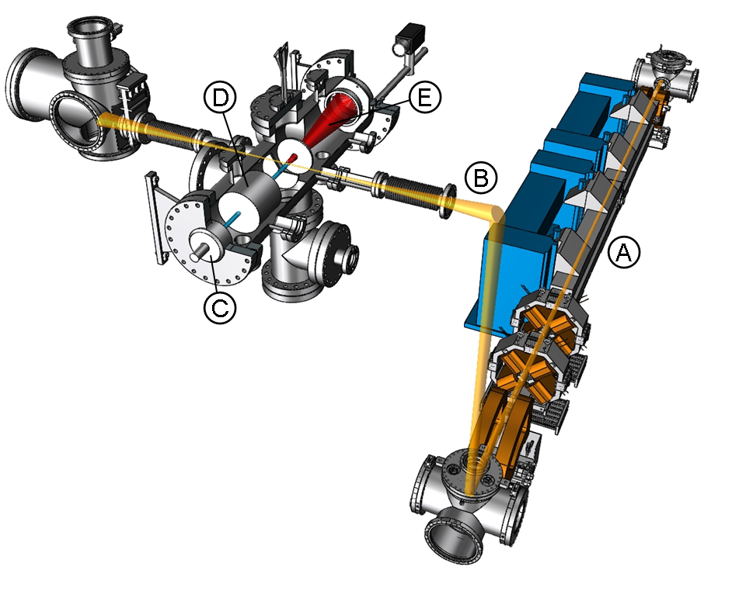
Fig. S1: Overview of the experimental setup. A velocity map imaging (VMI) spectrometer was integrated in the Free Electron Laser for Intra-Cavity Experiments (FELICE) at the FELIX facility in the Netherlands (17). Metastable Xenon atoms formed by electron impact excitation were ionized by the mid-infrared radiation, producing electrons that were projected upon a position-sensitive detector. The measured projection can be used to determine the angular and kinetic energy distribution of the electrons. Description of labeled components: (A) the accelerator and undulator of the FEL where the infrared radiation was generated; (B) upper arm of the FEL cavity, which is built up from 4 mirrors, two of which are on either side of the undulator and two of which are (one floor higher) in the experimental hall, producing a focus in between; (C) pulsed gas valve used for injecting the Xenon atoms into the instrument; (D) electron impact assembly that promoted the Xenon atoms to a metastable state; (E) VMI spectrometer where electrons produced by the ionization of metastable atoms by the FEL were detected.

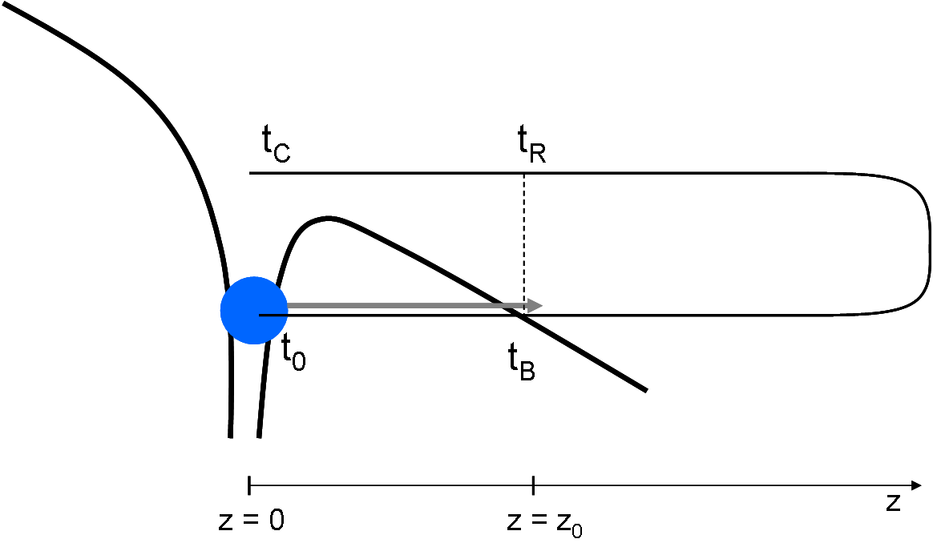
Fig. S2. Schematic drawing of the path that an electron follows in a strong laser field under the barrier and in the continuum. The thick black line represents the combined laser and Coulomb fields that the electron experiences. The path followed by the electron is indicated by the thin black line. Tunneling starts at complex time t₀. At ‘birth time’ t_{B} the instantaneous electron velocity is equal to zero. In the classical three-step model this moment corresponds to the instant when the electron comes out of the barrier at a distance z₀. Once in the continuum, the electron makes an excursion in the laser field before coming back to z₀ at the return time t_{R}. At t_{C} the electron is back at the origin where it scatters.
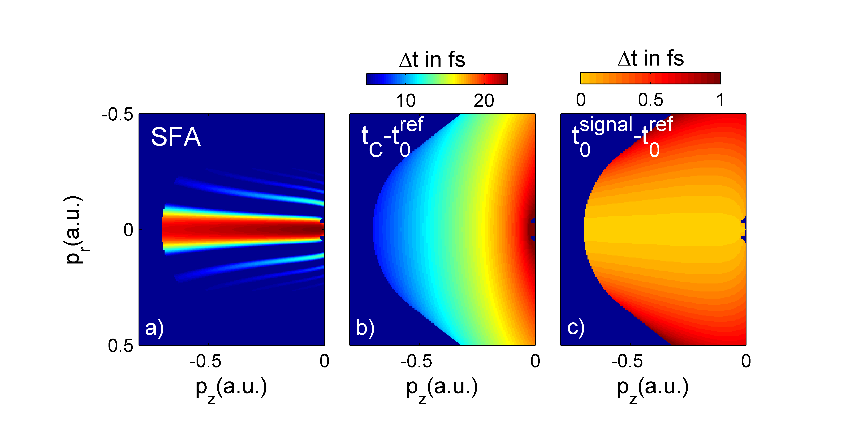Fig. S3. SFA calculation on Holography. (A) SFA calculation of a hologram, where a coherent electron source is created at distance z₀ from the ion by tunnel ionization and where the subsequent propagation of the electron wave packet under the influence of the laser field leads to the creation of a reference and signal beam. The calculation is performed with the experimental values for F_{laser}, λ_{laser} and IP (see article). (B) Relation between (p_{z}, p_{r}) and the time difference t_{C} – t₀^{ref}, suggesting that the hologram can be thought of as a pump-probe experiment that records dynamics in the ionic core. (C) Relation between (p_{z}, p_{r}) and the time difference t_{B}^{ref}- t₀^{signal}, suggesting that the hologram can measure the time evolution of the ionization process.

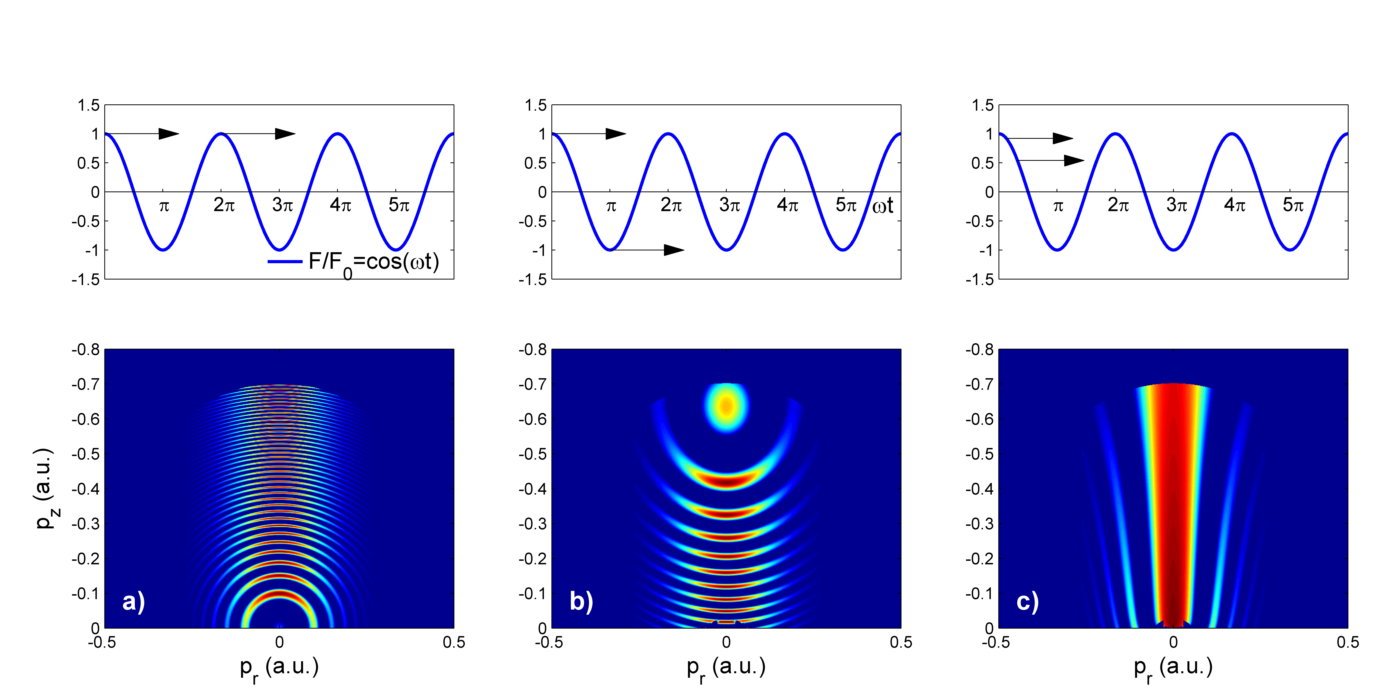
Fig. S4. Three different types of interferometric structures in photoelectron spectra accompanying strong field ionization (lower panel), corresponding to different types of interfering electron trajectories originating either from different quarter-cycles of the laser field (upper panel (A,B) or the same quarter-cycle (upper panel (C)). All spectra have been calculated with F = 0.0045a.u. IP = 0.14 a.u. ω=0.00641 a.u. and are based on Eqs (S22) and (S23). (A) Two wave packets ionized with exactly one cycle relative delay. The resulting pattern consists of rings that are spaced by the energy of one photon. This behavior is usually described by the term Above Threshold Ionization (ATI). (B) Interference between two wave packets that are ionized within the same cycle but appear on opposite sides of the ion, see text. This type of interference has been experimentally observed (S1, S3) and described theoretically (S4). (C) Holographic pattern that arises from the interference between two electron wave packets that are emitted during the same quarter cycle of the laser field. One wave packet goes to the detector without scattering from the short-range part of the target potential, while the other wave packet scatters off this potential before reaching the detector.

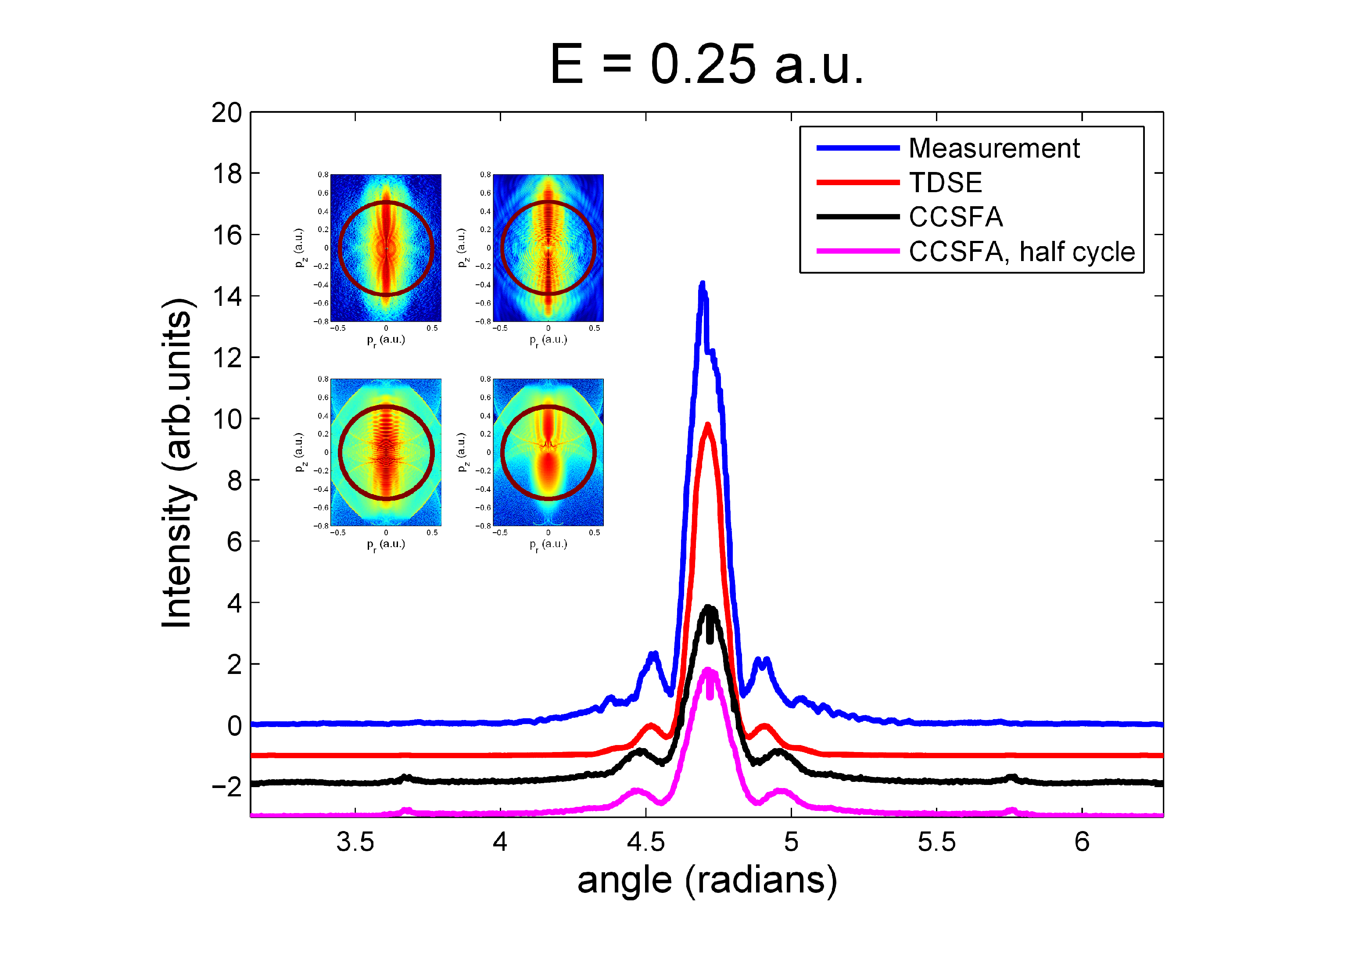Fig. S5 Line outs to quantitatively compare the TDSE and CCSFA calculation to the experimental data. In this plot the signal is plotted against the emission angle with respect to the laser polarization axis for a photoelectron kinetic energy of 0.25 a.u. The inset illustrates where the line outs originate in the original momentum maps.
References
S1. F. Lindner et al., Phys. Rev. Lett. 95, 040401 (2005).
S2. A. Becker, F.H.M. Faisal, J. Phys. At. Mol. Opt. Phys. 38, R1 (2005).
S3. R. Gopal et al., Phys. Rev. Lett. 103, 053001 (2009).
S4. D.G. Arbo, E. Persson, J. Burgdorfer, Phys. Rev. A 74, 063407 (2006).
S5. O. Smirnova, M. Spanner, M. Ivanov, Phys. Rev. A 77, 033407 (2008).
S6. M. Y. Ivanov, M. Spanner, O. Smirnova, J. Mod. Opt. 52, 165 (2005).

